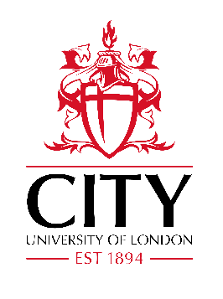

Role and Responsibilities for External Advisors on the HEA RISES Scheme
The appointment of External Advisors for the Recognising Individual Staff Education Status (RISES) scheme is to ensure there is some externality and transparency in the process of assessing fellowship claims from staff. The External Advisor is appointed for a period of four years. During the role the following responsibilities should be undertaken:
- Participate in the assessment of all Principal and Senior Fellowship claims
- Participate in the sampling of Fellowship and Associate Fellowship claims
- Return any assessment documentation to the RISES Scheme Leader at the time agree prior to the board so papers can be collated for the board
- Participate in three panel meetings per year preferable face to face but in a situation where this is not possible other arrangements will be made
- Provide feedback at the meeting about the process
- Provide a written annual report on the scheme
- Raise with the scheme leader any concerns about the process of assessing claims

Annual training will be provided for panel members and the external advisor may wish to participate in this.

