

City, University of London
Staff and Student Equality Monitoring Report
2018-2019

INTRODUCTION

Equality Act 2010 - Public Sector Equality Duties
The Public Sector Equality Duty (PSED) came into force on 5th April 2010. In England the Equality Act 2010 (specific duties and public authorities) Regulations came into force on 31 March 2017 replacing the Equality Act 2010 (specific duties) Regulations 2011.

Aims of the General Duty
In the exercise of their functions public authorities of which City is one, must have due regard to the need to:
- Eliminate unlawful discrimination, harassment and victimisation and other conduct prohibited by the Act
- Advance equality of opportunity between people who do and do not share a protected characteristic
- Foster good relations between people who do and do not share a protected characteristic.

Management Information Data
The commentary and data outlined below shows City, University of London's activity and monitoring information. City is committed to improving and extending the gathering of data across its functions, to enable continued monitoring of the impact of decisions and practices for staff with protected characteristics.
Equality Objectives 2017-2019
As a Higher Education Institution we have specific equality duties, as outlined by the Equality Act (2010). These require public authorities to tackle discrimination, victimisation and harassment, advance equality and foster good relations. It is also our responsibility to publish our equality information on an annual basis to review and publish specific and measurable equality objectives every four years. In 2016/17 City set a number of Equality Objectives:

Objective 1
To promote Gender Equality and impact positively on other equality areas, including intersectionality, in order to build and maintain an inclusive environment that supports and values the diversity of students, staff and the wider community.
Arising from the Athena SWAN Bronze Award and Action Plan, there are two Performance Indicators that support this objective:

Performance Indicator 1. Increasing the representation of women in senior roles:
- The proportion (of base population) of Professorial staff will be ~30% women by 2020/21
- The proportion of Grade 9 Professional Services staff will be ~50% women by 2020/21.
Performance Indicator 2. Increasing the representation of women on executive/institutional committees:
- We expect diverse membership on our executive/institutional committees, with a minimum of 30% women and 30% men on each committee.

Objective 2
- To consider and prepare for the Equality Challenge Unit’s Race Equality Charter with a view to submitting an application by 2018/19.

City is developing a new Equality, Diversity and Inclusion Strategy which will lead to revised objectives.
Part 1: Staff
The data:
This section presents City’s staff equality data for the academic years 2016/17 to 2018/19. City currently monitors eight protected characteristics defined by the Equality Act 2010. The characteristics covered are Gender/Sex, Maternity, Race, Disability, Sexual Orientation, Religion and Belief, Age and Gender Reassignment. The proportion of staff disclosing as being in a gender identity different to that assigned at birth was insufficient for statistical analysis and is not included in this report.
The data used for this report includes all salaried staff who were employed at City at the 31st July each academic year. Turnover data calculations use average headcount at the institution throughout the year.
In the tables throughout the staff report * indicates where staff numbers are fewer than five.
Where possible, the report comparisons are made with the most recent Higher Education Statistics Agency (HESA) data from 2017/18.
Section 1: Overview
In 2018/19 City employed 2,174 staff comprising 952 Academic and Research (44%) and 1222 Professional Service Staff (PSS) (56%).
Figure 1 Staff breakdown by Academic and Professional Service Staff

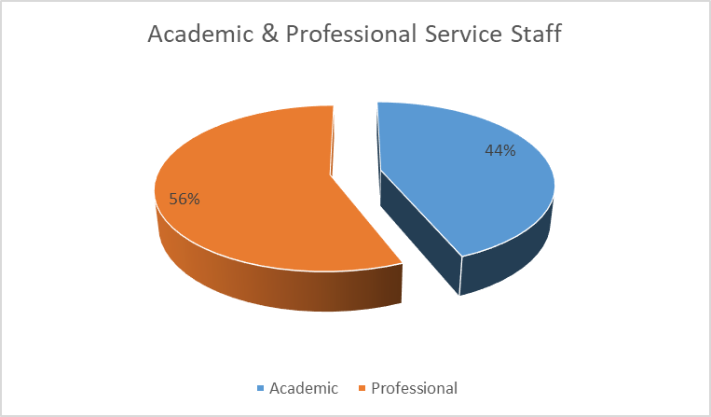

Section 2: Gender
Table 1 - Gender: Academic and Professional Service Staff by Role (2016-2019)
 | 2016/17 |  |  |  | 2017/18 |  |  |  | 2018/19
 | Women | Men | W % | W %* | W | M | W% | W%* | W | M | W % | W %*
Academic | 367 | 502 | 42.2% | 100% | 390 | 500 | 43.8% | 100% | 437 | 515 | 45.9% | 100%
Research | 59 | 83 | 41.5% | 16.1% | 70 | 76 | 47.9% | 17.9% | 93 | 83 | 52.8% | 21.3%
Lecturer | 111 | 90 | 55.2% | 30.2% | 111 | 96 | 53.6% | 28.5% | 127 | 106 | 54.5% | 29.1%
Senior Lecturer | 117 | 132 | 47% | 31.9% | 127 | 136 | 48.3% | 32.6% | 136 | 133 | 50.6% | 31.1%
Reader | 31 | 31 | 50% | 8.4% | 30 | 34 | 46.9% | 7.7% | 26 | 38 | 40.6% | 5.9%
Professor | 49 | 166 | 22.8% | 13.4% | 52 | 158 | 24.8% | 13.3% | 55 | 155 | 26.2% | 12.6%
Professional Services | 613 | 499 | 55.1% | 100% | 649 | 518 | 55.6% | 100% | 699 | 523 | 57.2% | 100%
Technical | * | 18 | 5.3% | 0.2% | * | 21 | 4.5% | 0.2% | * | 21 | 12.5% | 0.4%
Support | * | 18 | 5.3% | 0.2% | * | 18 | 5.3% | 0.2% | * | 15 | 6.3% | 0.1%
Clerical | 313 | 203 | 60.7% | 51.1% | 324 | 223 | 59.2% | 50% | 363 | 224 | 61.8% | 51.9%
SALC / Senior Admin | 298 | 260 | 53.4% | 48.6% | 323 | 256 | 55.8% | 50% | 332 | 263 | 55.8% | 47.5%
Total | 980 | 1001 | 49.5% | 100% | 1039 | 1018 | 50.5% | 100% | 1136 | 1038 | 52.3% | 100%
*% Women in each role measured against all women staff within Academic and Professional Services respectively

Figure 2 – Staff breakdown (2017/18) by role and gender
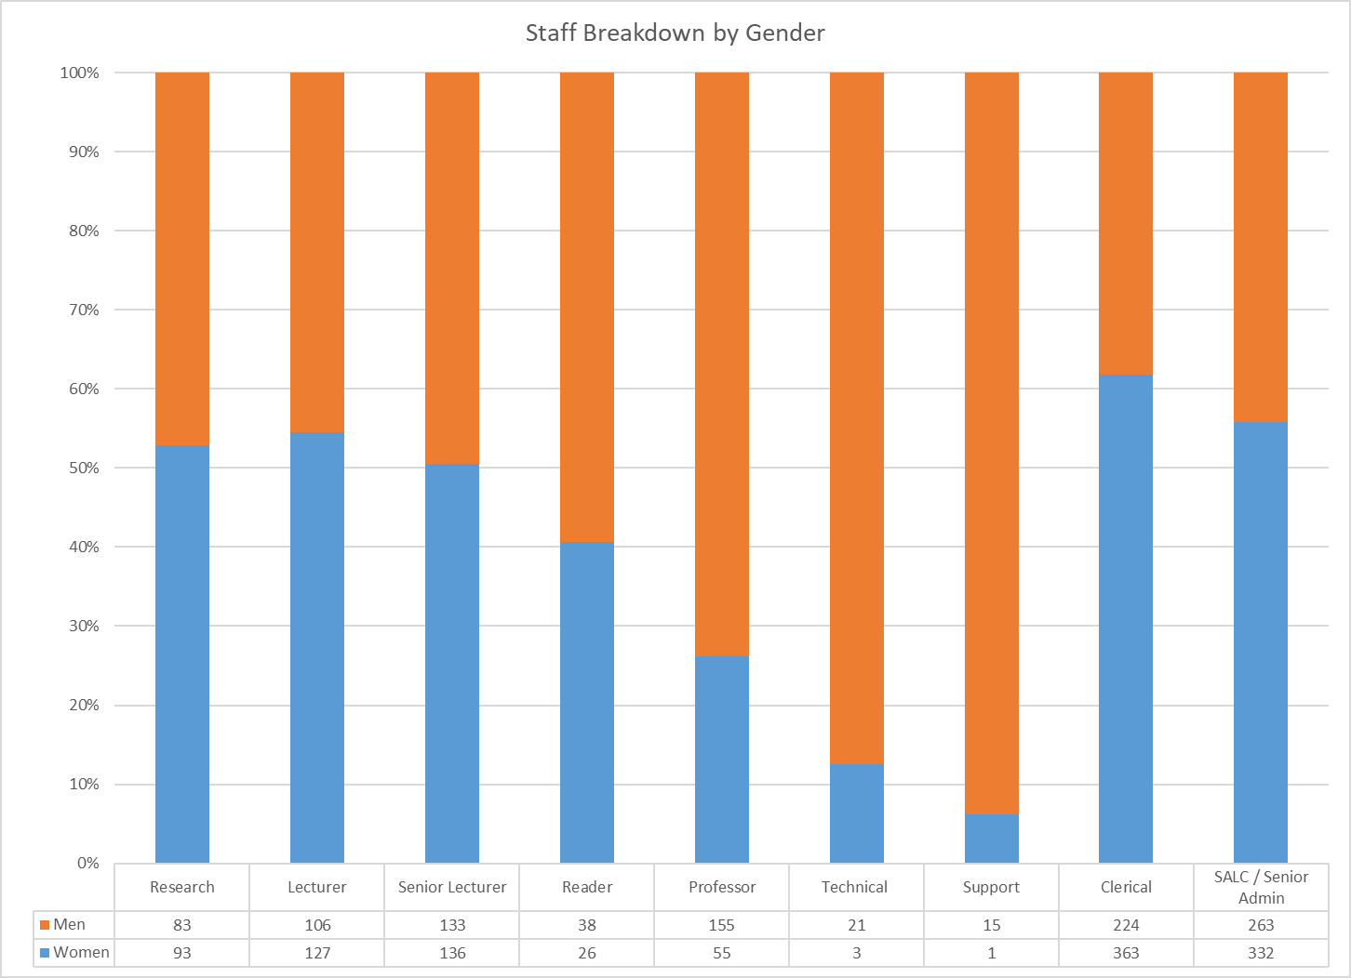
Overall at City in 2018/19 52% of staff were women. This has increased from 50% in 2016/17. Nationally the proportion of women was 52.75% (HESA). 57% of Professional Service Staff (PSS) staff were women in 2018/19. This has increased from 55% in 2016/17.
In 2018/19 46% of City’s academic staff were women, (44.2% nationally). This has increased from 42% in 2016/17. The proportion of women academic staff decreases with increasing role seniority, 26% of professorial staff were women in 2018/19 (Table 2).
Table 2 - Academic and Professional Service Staff by Grade & Gender 2018/19
 | Women | Men | Women % | Women %*
Academic | 437 | 515 | 45.9% | 100%
Grade 5B | 29 | 16 | 64.4% | 6.6%
Grade 6 | 65 | 65 | 50.0% | 14.9%
Grade 7 | 122 | 101 | 54.7% | 27.9%
Grade 8 | 166 | 178 | 48.3% | 38.0%
Professor | 55 | 155 | 26.2% | 12.6%
Professional Services | 699 | 523 | 57.2% | 100%
Grade 1 |  | 14 | 0.0% | 0%
Grade 2 | 10 | 17 | 37.0% | 1.4%
Grade 3 | 27 | 38 | 41.5% | 3.9%
Grade 4 | 85 | 42 | 66.9% | 12.2%
Grade 5 | 245 | 142 | 63.3% | 35.1%
Grade 6 | 185 | 123 | 60.1% | 26.5%
Grade 7 | 104 | 91 | 53.3% | 14.9%
Grade 8 | 29 | 37 | 43.9% | 4.1%
Grade 9 | 14 | 19 | 42.4% | 2.0%
Total | 1136 | 1038 | 52.3% | 100%
*% Women at each grade measured against all women staff within Academic and Professional Services respectively
For PSS staff the largest proportion of women were at Grade 4, 67% in 2018/19, although of PSS that are women, 35% are at Grade 5. Above Grade 5 the proportion of women by grade continues to decrease to 42% women at Grade 9.

Table 3 - Academic and Professional Service Staff by School & Gender 2018/19
 | Women | Men | Women % | Women %*
Academic | 437 | 515 | 45.9% | 100%
Cass Business School | 58 | 133 | 30.4% | 13.3%
Professional Services | 10 | * | 71.4% | 2.3%
School of Arts and Social Sciences | 123 | 110 | 52.8% | 28.1%
School of Health Sciences | 160 | 59 | 73.1% | 36.6%
School of Mathematics, Computer Science and Engineering | 36 | 155 | 18.8% | 8.2%
The City Law School | 50 | 54 | 48.1% | 11.4%
Professional Services | 699 | 523 | 57.2% | 100%
Cass Business School | 119 | 55 | 68.4% | 17.0%
Professional Services | 418 | 390 | 51.7% | 59.8%
School of Arts and Social Sciences | 45 | 19 | 70.3% | 6.4%
School of Health Sciences | 58 | 17 | 77.3% | 8.3%
School of Mathematics, Computer Science and Engineering | 36 | 32 | 52.9% | 5.2%
The City Law School | 23 | 10 | 69.7% | 3.3%
Total | 1136 | 1038 | 52.3% | 100%
*% Women within each School measured against all Women in Academic and Professional Services respectively
The School of Health Sciences (SHS) has the largest proportion of women academic staff, 71% in 2018/19. The School of Mathematics, Computer Science and Engineering (SMCSE) has the lowest proportion of women academic staff, 19% in 2018/19 (Table 3).
Across all five Schools there is a high proportion of women Professional Services Staff. SHS has the highest proportion of women PSS, 77%.
Contract type
Table 4 - Academic and Professional Service Staff by Contract Type and Gender 2018/19
 | Women | Men | Women % | Women % *
Academic | 437 | 515 | 45.9% | 100%
Fixed term | 42 | 35 | 54.5% | 9.6%
Permanent | 395 | 480 | 45.1% | 90.4%
Professional Services | 699 | 523 | 57.2% | 100%
Fixed term | 71 | 36 | 66.4% | 10.2%
Permanent | 628 | 487 | 56.3% | 89.8%
Total | 1136 | 1038 | 52.3% | 100%
*% Women within each contract type measured against all Women in Academic and Professional Services respectively
In 2018/19 of academics on permanent contracts 45% were women, which compares with 43% nationally. For academic women staff, 9.6% were on fixed-term contracts, which compares well to 47% of women nationally.

For PSS of those on fixed-term contracts 66% were women in 2018/19, nationally 64%. For those on permanent contracts 56% were women which is lower than the national data of 60%.
Full-time or Part-time Status
Table 5 - Academic and Professional Service Staff by Full-time/Part-time status and Gender 2018/19
 | Women | Men | Women % | Women %*
Academic | 437 | 515 | 45.9% | 100%
Full time | 287 | 424 | 40.4% | 65.7%
Part time | 150 | 91 | 62.2% | 34.3%
Professional Services | 699 | 523 | 57.2% | 100%
Full time | 590 | 494 | 54.4% | 84.4%
Part time | 109 | 29 | 79.0% | 15.6%
Total | 1136 | 1038 | 52.3% | 100%
*% Women with Full-time/ Part-time status measured against all Women in Academic and Professional Services respectively
For academic staff that work part-time 62% were women in 2018/19, compared to 59% nationally. For PSS that work part-time 79% were women in 2017/18, compared to 82% nationally (Table 5).
Turnover and Reasons for leaving
Table 6 - Academic and Professional Services Staff Turnover by Role and Gender - 2018/19
 | Women Turnover |  |  | Men Turnover |  |  | Overall Turnover
 | Headcount | Leavers | % | Headcount | Leavers | % | Headcount | Leavers | %
Academic | 437 | 58 | 13.3% | 515 | 68 | 13.2% | 952 | 126 | 13.2%
Research | 93 | 33 | 35.5% | 83 | 37 | 44.6% | 176 | 70 | 39.8%
Lecturer | 127 | 12 | 9.4% | 106 | 7 | 6.6% | 233 | 19 | 8.2%
Senior Lecturer | 136 | 9 | 6.6% | 133 | 15 | 11.3% | 269 | 24 | 8.9%
Reader | 26 | 0 | 0.0% | 38 | * | 2.6% | 64 | * | 1.6%
Professor | 55 | * | 7.3% | 155 | 8 | 5.2% | 210 | 12 | 5.7%
Professional Services | 699 | 114 | 16.3% | 523 | 76 | 14.5% | 1222 | 190 | 15.5%
Technical Staff | * | 0 | 0.0% | 21 | 5 | 23.8% | 24 | 5 | 20.8%
Support Staff | * | 0 | 0.0% | 15 | * | 20.0% | 16 | * | 18.8%
Clerical | 363 | 68 | 18.7% | 224 | 33 | 14.7% | 587 | 101 | 17.2%
SALC | 332 | 46 | 13.9% | 263 | 35 | 13.3% | 595 | 81 | 13.6%
Total | 1136 | 172 | 15.1% | 1038 | 144 | 13.9% | 2174 | 316 | 14.5%
*% Women leavers measured against all leavers
The annualised total turnover rate for City was 14.5% during 2018/19 (Table 6). This is broadly consistent with the turnover rate in 2017/18 (14.3%). The turnover for Research staff was the largest, 39.8%, as would be expected given the nature of funding for these roles. Reader/Associate Professor had the lowest turnover at 1.6%. Overall the turnover of women staff is higher than men, 15.1% compared to 13.9%.

Table 7 - Leaving Reason: Academic and Professional Services Staff by Gender - 2018/19
 | Women | Men | Women % | Women %*
Academic | 58 | 68 | 46.03% | 100%
Expiry of contract | 24 | 25 | 49.0% | 41.4%
Other | * | * | 50.0% | 1.7%
Redundancy | 5 | 9 | 35.7% | 8.6%
Resignation | 25 | 31 | 44.6% | 43.1%
Retirement | * | * | 60.0% | 5.2%
Professional Services | 114 | 76 | 60% | 100%
Expiry of contract | 10 | 6 | 62.5% | 8.8%
Other | * | * | 33.3% | 2%
Redundancy | 12 | * | 80.0% | 10.5%
Resignation | 88 | 61 | 59.1% | 77.2%
Retirement | * | * | 50.0% | 2%
Total | 172 | 144 | 54.4% | 100%
The most frequent reason for leaving was resignation (Table 7). For academic staff the proportion of women leavers was 46% which is in line with the proportion of women academics at City, (46%, 2018/19 – Table 1). For PSS 60% of leavers were women, which is in line with their representation at City.
Maternity, paternity, shared parental and adoption leave
Table 8 - Staff Returning from Maternity Leave
Year | 2015/16 | 2016/17 | 2017/18 | 2018/19
% Returned | 83.7% | 95.8% | 80% | 86.8%
*2017/18 & 2018/19 – Reflects those whose maternity leave ended in that academic year (Athena SWAN data)
The number of staff returning after maternity leave has remained above 80%.
Table 9 - Shared Parental, Parental & Paternity Leave - 2016-2019
Year | Women | Men | Total
2016/17 |  | 28 | 28
Parental Leave
Paternity Leave |  | 24 | 24
Shared Parental |  | * | *
2017/18 | * | 17 | 19
Parental Leave
Paternity Leave |  | 16 | 16
Shared Parental | * | * | *
2018/19 | * | 16 | 19
Parental Leave
Paternity Leave |  | 15 | 15
Shared Parental |  | * | *
Total | * | 61 | 66

In 2018/19 19 staff took paternity or shared parental leave, this has decreased from 28 in 2016/17.
Section 3: Ethnicity
Throughout this section data is presented by ethnicity, and split by White, BAME and Refused/Not known. BAME includes staff who disclose as Black, Asian, or Minority Ethnic. Calculations include only those who have disclosed an ethnicity e.g., Refused/Not known are excluded.
Table 10 - Ethnicity: Academic and Professional Service Staff by Residency Status
 | BAME | White | Refused / Not known | % BAME | % BAME^ | % White | % White^
Academic | 161 | 768 | 23 | 17.3% | 100% | 82.7% | 100%
UK | 82 | 466 | 13 | 15% | 50.9% | 85.0% | 60.7%
Non UK | 79 | 302 | 10 | 21% | 49.1% | 79.3% | 39.3%
Professional Services | 393 | 801 | 28 | 32.9% | 100% | 67.1% | 100%
UK | 354 | 657 | 22 | 35% | 90.1% | 65.0% | 82.0%
Non UK | 39 | 144 | 6 | 21.3% | 9.9% | 78.7% | 18.0%
Total | 554 | 1569 | 51 | 26.1% | 100% | 73.9% | 100%
*Calculations include only those who have disclosed their ethnicity
^ Measured against all BAME or white staff within Academic and Professional Services respectively
Overall 26% of City staff were BAME in 2018/19, this has increased from 24% in 2016/17 and 25% in 2017/18. 15% of UK academics at City were BAME in 2018/19 which is the same proportion as reported in 2017/18.
Figure 3 – Academic & Research and Professional Service Staff by ethnicity – 2017/18
Academic & Research Staff | Professional Service Staff
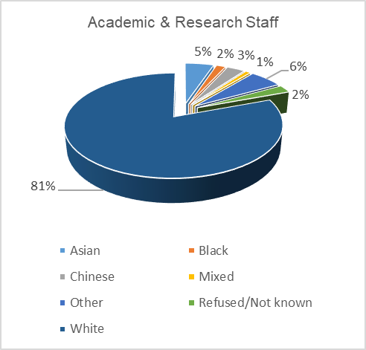 | 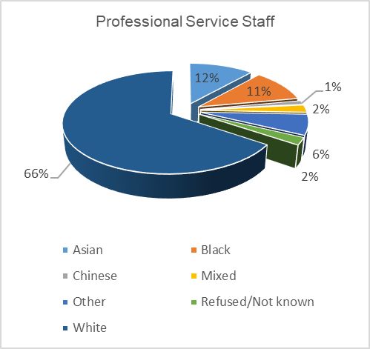

Table 11 - Academic and Professional Service Staff by Role & Ethnicity (2016/19)
Academic | 2016/17 |  |  |  | 2017/18 |  |  |  | 2018/19
Academic | BAME | White | Refused / Not known | % BAME | BAME | White | Refused / Not Known | % BAME | BAME | White | Refused / Not Known | % BAME
Academic | 141 | 706 | 22 | 16.6% | 146 | 720 | 24 | 16.9% | 161 | 768 | 23 | 17.3%
Research | 42 | 94 | 6 | 30.9% | 38 | 99 | 9 | 27.7% | 44 | 125 | 7 | 26.0%
Lecturer | 37 | 159 | 5 | 18.9% | 42 | 162 | * | 20.6% | 50 | 179 | * | 21.8%
Senior Lecturer | 33 | 212 | * | 13.5% | 36 | 222 | 5 | 14% | 36 | 229 | * | 14%
Reader | 7 | 54 | * | 11.5% | 7 | 56 | * | 11.1% | 7 | 55 | * | 11.3%
Professor | 22 | 187 | 6 | 10.5% | 23 | 181 | 6 | 11.3% | 24 | 180 | 6 | 11.8%
Professional Services | 316 | 776 | 20 | 28.9% | 349 | 798 | 20 | 30.4% | 393 | 801 | 28 | 32.9%
Clerical | 183 | 319 | 14 | 36.5% | 212 | 325 | 10 | 39.5% | 242 | 329 | 16 | 42.4%
Support | 10 | 8 | * | 55.6% | 11 | 7 | * | 61.1% | 11 | * | * | 73.3%
Technical | * | 15 |  | 21.1% | 5 | 17 |  | 22.7% | 7 | 17 |  | 29.2%
SALC / Senior Admin | 119 | 434 | 5 | 21.5% | 121 | 449 | 9 | 21.2% | 133 | 451 | 11 | 22.8%
Total | 457 | 1482 | 42 | 23.6% | 495 | 1518 | 44 | 24.6% | 554 | 1569 | 51 | 26.1%

Figure 4 – Staff breakdown (2017/18) by ethnicity and role
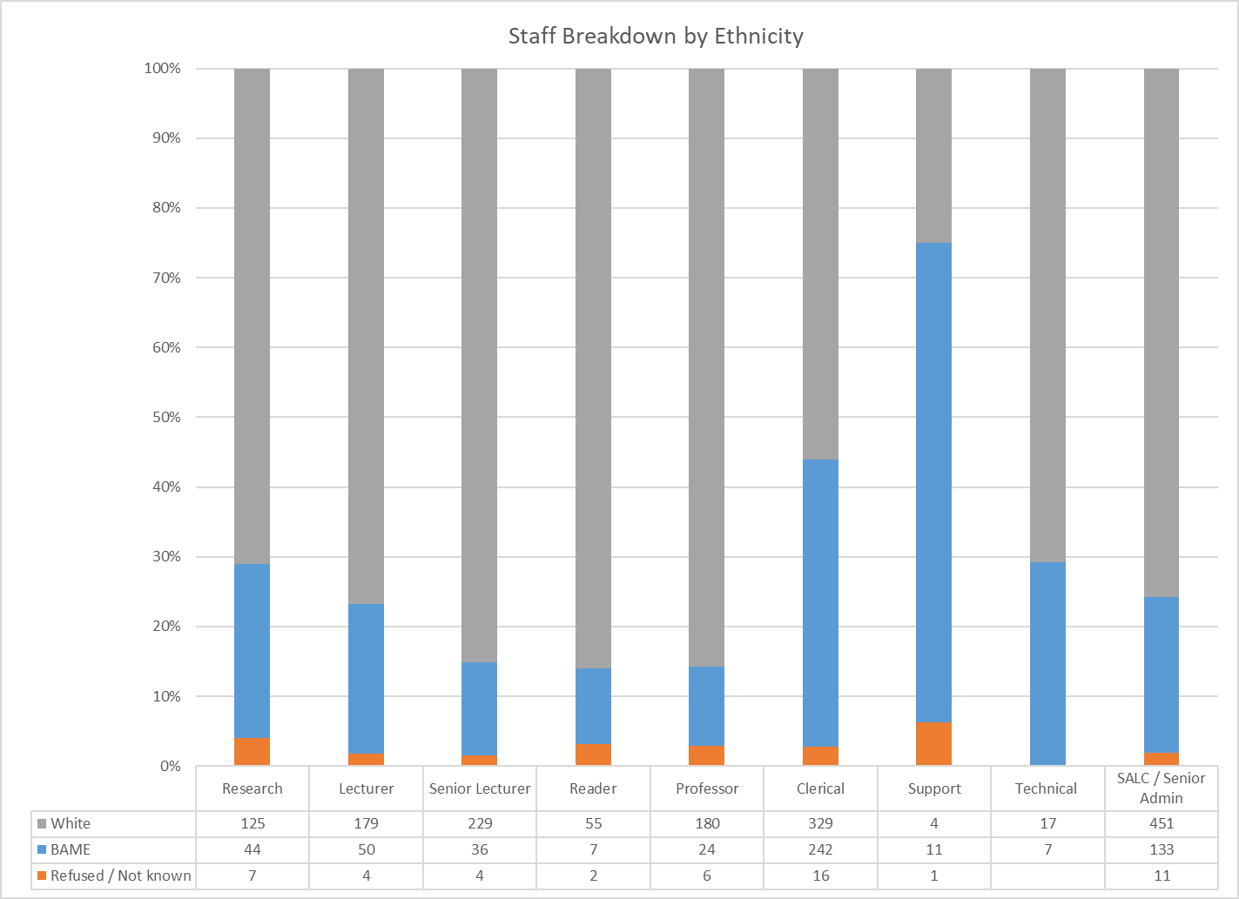
For academic staff 17% were BAME in 2018/19 (Table 11) representing a gradual increase since 2016/17. By role the proportion of BAME academic staff decreases from 26% of Research staff to 12% of Professors. For PSS 33% were BAME in 2018/19, which has increased from 29% in 2016/17.
Table 12 - Academic and Professional Service Staff by School & Ethnicity - 2018/19
 | BAME | White | Refused / Not Known | % BAME
Academic | 161 | 768 | 23 | 17.3%
Cass Business School | 33 | 152 | 6 | 18%
School of Arts and Social Sciences | 30 | 198 | 5 | 13%
School of Health Sciences | 21 | 194 | * | 10%
School of Mathematics, Computer Science and Engineering | 58 | 128 | 5 | 31%
The City Law School | 19 | 82 | * | 19%
Professional Services |  | 14 |  | 0%
Professional Services | 393 | 801 | 28 | 32.9%
Cass Business School | 50 | 121 | * | 29.2%
School of Arts and Social Sciences | 15 | 49 |  | 23.4%
School of Health Sciences | 35 | 38 | * | 47.9%
School of Mathematics, Computer Science and Engineering | 26 | 40 | * | 39.4%
The City Law School | 9 | 23 | * | 28%
Professional Services | 258 | 530 | 20 | 32.7%
Total | 554 | 1569 | 51 | 26.1%
*Calculations include only those who have disclosed their ethnicity
The School with the highest proportion of BAME staff is SMCSE with 31% BAME academic staff and 39% BAME PSS.
Contract Type
Table 13 - Ethnicity: Academic and Professional Services by Contract Type & Ethnicity
 | BAME | White | Refused / Not Known | % BAME | % BAME^ | % White | % White^
Academic | 161 | 768 | 23 | 17.3% | 100% | 82.7% | 100%
Fixed term | 17 | 60 |  | 22.1% | 10.6% | 77.9% | 8%
Permanent | 144 | 708 | 23 | 16.9% | 89.4% | 83.1% | 92%
Professional Services | 393 | 801 | 28 | 32.9% | 100% | 67.1% | 100%
Fixed term | 48 | 56 | * | 46.2% | 12.2% | 53.8% | 7%
Permanent | 345 | 745 | 25 | 31.7% | 87.8% | 68.3% | 93%
Total | 554 | 1569 | 51 | 26.1% | 96.9% | 73.9% | 100%
*Calculations include only those who have disclosed their ethnicity
^ Measured against all BAME or white staff within Academic and Professional Services respectively
For BAME academic staff 10.6% were on fixed term contracts, which is higher than the proportion of white academic staff on fixed term contracts (8%). For PSS there was a higher proportion of BAME staff on fixed-term contracts, 12.2%, than White staff 7%.
Part-time work
Table 14 - Academic and Professional Services by Full-time / Part-time & Ethnicity
 | BAME | White | Refused / Not Known | % BAME | % BAME^ | % White | % White^
Academic | 161 | 768 | 23 | 17.3% | 100% | 82.7% | 100%
Full time | 133 | 563 | 15 | 19% | 83% | 80.9% | 73%
Part time | 28 | 205 | 8 | 12% | 17% | 88.0% | 27%
Professional Services | 393 | 801 | 28 | 32.9% | 100% | 67.1% | 100%
Full time | 357 | 707 | 20 | 34% | 91% | 66.4% | 88%
Part time | 36 | 94 | 8 | 27.7% | 9% | 72.3% | 12%
Total | 554 | 1569 | 51 | 26% | 97% | 73.9% | 100%
*Calculations include only those who have disclosed their ethnicity
^ Measured against all BAME or white within Academic and Professional Services respectively
For academic BAME staff 17% work part-time, compared to 27% of white academic staff. Of BAME PSS 9% work part-time compared to 12% of white PSS staff.

Turnover and Reasons for leaving

Table 15 - Academic and Professional Services Staff by Role & Turnover & Ethnicity
Academic | BAME Turnover |  |  | White Turnover |  |  | Refused / Not Known Turnover |  |  | Total Turnover
Academic | BAME | Leaver | % | White | Leaver | % | Refused | Leaver | % | Total | Leaver | %
Academic | 161 | 25 | 15.5% | 768 | 96 | 12.5% | 23 | 5 | 21.7% | 952 | 126 | 13.2%
Research | 44 | 20 | 45% | 125 | 45 | 36.0% | 7 | 5 | 71.4% | 176 | 70 | 39.8%
Lecturer | 50 | * | 6.0% | 179 | 16 | 8.9% | * | 0 | 0.0% | 233 | 19 | 8.2%
Senior Lecturer | 36 | * | 2.8% | 229 | 23 | 10.0% | * | 0 | 0.0% | 269 | 24 | 8.9%
Reader | 7 | 0 | 0% | 55 | * | 1.8% | * | 0 | 0.0% | 64 | * | 1.6%
Professor | 24 | * | 4.2% | 180 | 11 | 6.1% | 6 | 0 | 0.0% | 210 | 12 | 5.7%
Professional Services | 393 | 58 | 14.8% | 801 | 129 | 16.1% | 28 | * | 10.7% | 1222 | 190 | 16%
Technical Staff | 7 | * | 14% | 17 | * | 23.5% | 0 | 0 | 0.0% | 24 | 5 | 20.8%
Support Staff | 11 | 0 | 0.0% | * | * | 75.0% | * | 0 | 0.0% | 16 | * | 18.8%
Clerical | 242 | 39 | 16.1% | 329 | 61 | 18.5% | 16 | * | 6.3% | 587 | 101 | 17.2%
SALC | 133 | 18 | 13.5% | 451 | 61 | 13.5% | 11 | * | 18.2% | 595 | 81 | 13.6%
Total | 554 | 83 | 15% | 1569 | 225 | 14.3% | 51 | 8 | 15.7% | 2174 | 316 | 14.5%
The turnover rate for BAME staff was 15%. This is lower than the turnover rate for BAME staff in 2017/18, 18%. However, this is higher than the turnover for White staff, 14%.
The turnover rate for BAME staff amongst researchers is 45% for BAME staff and is higher than the total turnover rate for this staff group, 39.8 (Table 15). Table 16 shows the reasons for leaving.
Table 16 - Academic and Professional Services Staff by Reason for Leaving by Ethnicity
 | BAME | White | Refused / Not Known | % BAME
Academic | 25 | 96 | 5 | 20.7%
Expiry of contract | 13 | 33 | * | 28.3%
Other |  | * |  | 0%
Redundancy | * | 12 |  | 14%
Resignation | 10 | 44 | * | 18.5%
Retirement |  | 5 |  | 0.0%
Professional Services | 58 | 129 | * | 31%
Expiry of contract | 7 | 9 |  | 44%
Other | * | * |  | 33.3%
Redundancy | 5 | 10 |  | 33.3%
Resignation | 44 | 102 | * | 30.1%
Retirement |  | * |  | 0.0%
Total | 83 | 225 | 8 | 26.9%
*Calculations include only those who have disclosed their ethnicity
When looking at the largest numbers of BAME staff leaving, this is either due to resignation or expiry of contract. For BAME PSS the largest reason for leaving was end of contract, 44%.

Section 4: Disability
Table 17 - Academic and Professional Service Staff by Disability Disclosure (2016-18)
 | 2016/17 |  | 2017/18 |  | 2018/19
Academic | 869 | % Academic | 890 | % Academic | 952 | % Academic
Disability | 45 | 5.2% | 48 | 5.4% | 51 | 5.4%
No known disability | 704 | 81% | 732 | 82.2% | 799 | 83.9%
Not known/refused | 120 | 13.8% | 110 | 12.4% | 102 | 10.7%
Professional Services | 1112 | % Professional | 1167 | % Professional | 1222 | % Professional
Disability | 47 | 4.2% | 56 | 4.8% | 61 | 5.0%
No known disability | 943 | 84.8% | 997 | 85.4% | 1052 | 86.1%
Not known/refused | 122 | 11% | 114 | 9.8% | 109 | 8.9%
All Staff | 1981 | % All Staff | 2057 | % All Staff | 2174 | % All Staff
Disability | 92 | 4.6% | 104 | 5.1% | 112 | 5.2%
No known disability | 1647 | 83.1% | 1729 | 84.1% | 1851 | 85.1%
Not known/refused | 242 | 12.2% | 224 | 10.9% | 211 | 9.7%
*Measured against all staff (whether declared or not)
The proportion of staff disclosing a disability at City has increased from 4.6% in 2016/17 to 5.2% in 2018/19. The 2017/18 Family Resources Survey reports that 18% of the working age population have a disability.
Table 18 shows the proportions of disclosed disability types at City. It should also be noted that whilst City’s disclosure of mental health conditions is better that the national UK HE data, the national Thriving at Work report, 2017, shows that around 15% of people at work have symptoms of an existing mental health condition.
Table 18 Disability Disclosure - breakdown | City  (31.07.19)
A long standing illness or health condition (e.g. Cancer) | 25.9%
A specific learning difficulty (e.g. Dyslexia or Dyspraxia) | 24.1%
A mental health condition (e.g. Depression or Schizophrenia) | 12.5%
A disability, impairment or medical condition not listed | 10.7%
A physical impairment or mobility issues (e.g. Wheelchair) | 6.3%
Deaf or serious hearing impairment | 8.0%
Two or more impairments and/or disabling medical conditions | 7.1%
Blind or a serious visual impairment uncorrected by glasses | 3.6%
General learning disability (e.g. Down's syndrome) | 1.8%
Total | 100%

Contract type
Table 19 - Academic and Professional Service Staff by Contract Type & Disability Disclosure 2018/19
 | Disability | No known disability | Not known/refused | % with Disability | % with Disability^
Academic | 51 | 799 | 102 | 5.4% | 100%
Fixed term | 6 | 67 | * | 7.8% | 11.8%
Permanent | 45 | 732 | 98 | 5.1% | 88.2%
Professional Services | 61 | 1052 | 109 | 5.0% | 100%
Fixed term | 7 | 95 | 5 | 6.5% | 11%
Permanent | 54 | 957 | 104 | 4.8% | 89%
Total | 112 | 1851 | 211 | 5.2% | 100%
*Measured against all staff (whether declared or not)
^ Measured against all disabled staff within Academic and Professional Services respectively
For academic staff 7.8% of those with a disability are on fixed-term contracts, compared to 3.7% nationally. For PSS on fixed term contracts 6.5% have a disability, which is higher than the national data of 5.9%.
Full-time or part-time status
Table 20 - Academic and Professional Service Staff by Full-time / Part-time & Disability Disclosure 2018/19
 | Disability | No known disability | Not known/refused | % with Disability* | % with Disability^
Academic | 51 | 799 | 102 | 5.4% | 100%
Full time | 39 | 603 | 69 | 5.5% | 76%
Part time | 12 | 196 | 33 | 5.0% | 24%
Professional Services | 61 | 1052 | 109 | 5.0% | 100%
Full time | 58 | 925 | 101 | 5.4% | 95%
Part time | * | 127 | 8 | 2.2% | 5%
Total | 112 | 1851 | 211 | 5.2% | 100%
*Measured against all staff (whether declared or not)
^ Measured against all disabled staff within Academic and Professional Services respectively
At City in 2018/19 17% of staff were part-time. For academic staff who declared a disability 24% were part-time, and PSS 5% were part-time.
Section 5: Age
Table 21 - Academic and Professional Staff by Age group 2016-19
 | 2016/17 |  | 2017/18 |  | 2018/19
 | No. | % | No. | % | No. | %
Academic | 869 | 100% | 890 | 100% | 952 | 100%
Under 25 | * | 0.5% | * | 0.3% | 5 | 1%
25 - 34 | 124 | 14.3% | 132 | 14.8% | 160 | 16.8%
35 - 44 | 246 | 28.3% | 253 | 28.4% | 268 | 28.2%
45 - 54 | 256 | 29.5% | 251 | 28.2% | 262 | 27.5%
55 - 64 | 172 | 19.8% | 192 | 21.6% | 188 | 19.7%
65 + | 67 | 7.7% | 59 | 6.6% | 69 | 7.2%
Professional Services | 1112 | 100% | 1167 | 100% | 1222 | 100%
Under 25 | 40 | 3.6% | 40 | 3.4% | 52 | 4.3%
25 - 34 | 361 | 32.5% | 380 | 32.6% | 389 | 31.8%
35 - 44 | 370 | 33.3% | 371 | 31.8% | 386 | 31.6%
45 - 54 | 225 | 20.2% | 247 | 21.2% | 256 | 20.9%
55 - 64 | 99 | 8.9% | 113 | 9.7% | 124 | 10.1%
65 + | 17 | 1.5% | 16 | 1.4% | 15 | 1.2%
All Staff | 1981 | 100% | 2057 | 100% | 2174 | 100%
Under 25 | 44 | 2.2% | 43 | 2.1% | 57 | 3%
25 - 34 | 485 | 24.5% | 512 | 24.9% | 549 | 25.3%
35 - 44 | 616 | 31.1% | 624 | 30.3% | 654 | 30.1%
45 - 54 | 481 | 24.3% | 498 | 24.2% | 518 | 23.8%
55 - 64 | 271 | 13.7% | 305 | 14.8% | 312 | 14.4%
65 + | 84 | 4.2% | 75 | 3.6% | 84 | 3.9%
The largest proportion of City’s staff are aged 35-44, comprising 30% of staff. For academic staff the largest age groups are 35-44 and 45-54. For PSS 25-34 and 35-44 are the largest age groups, 32% in 2018/19.
Figure 5 – Staff breakdown by age, academic and professional service staff
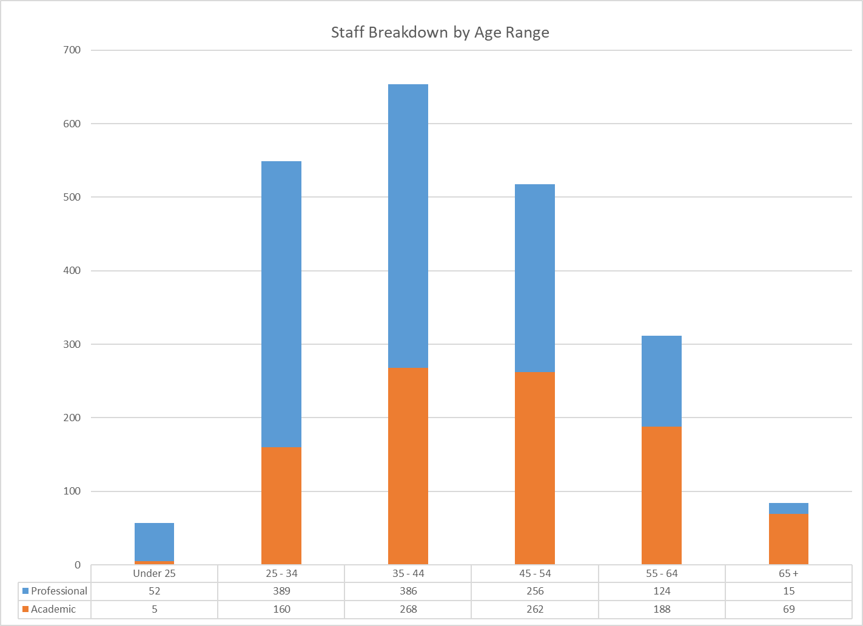

Table 22 - Academic Staff by Age Range and Role - 2016-19
Age Range | Research |  |  |  | Lecturer |  |  |  | Senior Lecturer |  |  |  | Reader |  |  |  | Professors
Age Range | 2016/17 | 2017/18 | 2018/19 | % | 2016/17 | 2017/18 | 2018/19 | % | 2016/17 | 2017/18 | 2018/19 | % | 2016/17 | 2017/18 | 2018/19 | % | 2016/17 | 2017/18 | 2018/19 | %
Under 25 | * | * | 5 | 3% |  |  |  | 0% |  |  |  | 0% |  |  |  | 0% |  |  |  | 0%
25 - 34 | 70 | 69 | 87 | 49% | 47 | 58 | 67 | 29% | 6 | * | 5 | 2% | * | * | * | 2% |  |  |  | 0%
35 - 44 | 45 | 51 | 50 | 28% | 77 | 75 | 92 | 39% | 84 | 92 | 85 | 32% | 20 | 20 | 25 | 39% | 20 | 15 | 16 | 8%
45 - 54 | 15 | 14 | 20 | 11% | 55 | 53 | 52 | 22% | 90 | 93 | 100 | 37% | 23 | 21 | 25 | 39% | 73 | 70 | 65 | 31%
55 - 64 | 6 | 6 | 10 | 6% | 21 | 20 | 18 | 8% | 56 | 65 | 68 | 25% | 17 | 22 | 13 | 20% | 72 | 79 | 79 | 38%
65 + | * | * | * | 2% | * | * | * | 2% | 13 | 9 | 11 | 4% | * |  |  | 0% | 50 | 46 | 50 | 24%
Total | 142 | 146 | 176 | 100% | 201 | 207 | 233 | 100% | 249 | 263 | 269 | 100% | 62 | 64 | 64 | 100% | 215 | 210 | 210 | 100%
*2017/18 & 2018/19 using Athena SWAN Data
For academic and research roles, the age group make-up can be linked to an increase in seniority. For example the largest age group for Researchers is 25-34, 49%, compared to Associate Professor/Professor where 0% of staff are aged 24-34. The largest group for Professors is 55-64, 38%.
Table 23 - Professional Services Staff by Age Range and Role - 2016-19
 | Clerical & Library |  |  |  | Support & Technical |  |  |  | SALC/ Senior Admin
Age Range | 2016/17 | 2017/18 | 2018/19 | %^ | 2016/17 | 2017/18 | 2018/19 | %^ | 2016/17 | 2017/18 | 2018/19 | %^
Under 25 | 39 | 39 | 51 | 8.7% | * |  |  | 0% |  | * | * | 0.2%
25 - 34 | 226 | 236 | 249 | 42.4% | 10 | 13 | 9 | 23% | 125 | 131 | 131 | 22.6%
35 - 44 | 142 | 144 | 152 | 25.9% | 6 | * | 7 | 18% | 222 | 223 | 227 | 38.5%
45 - 54 | 68 | 81 | 88 | 15.0% | 13 | 14 | 12 | 30% | 144 | 152 | 156 | 26.3%
55 - 64 | 34 | 41 | 41 | 7.0% | 5 | 7 | 8 | 20% | 60 | 65 | 75 | 11.2%
65 + | 7 | 6 | 6 | 1.0% | * | * | * | 10% | 7 | 7 | 5 | 1.2%
Total | 516 | 547 | 587 | 100% | 38 | 41 | 40 | 100% | 558 | 579 | 595 | 100%
For PSS staff by role, the largest group for staff in Support & Technical Roles are aged 45-54, 30%. For Clerical and Library Staff, 25-34 is the largest age group, however there is a higher proportion of staff in this age group, 42.4%. For SALC staff the largest age group is 35-44 with 38.5% of SALC staff in this age category
Contract Status

Table 24 - Academic and Professional Staff by Age Range & Contract Type - 2018/19
 | Fixed term | Permanent | % Fixed Term | % Fixed Term^
Academic | 77 | 875 | 8% | 100%
Under 25 | * | * | 20% | 1%
25 - 34 | 30 | 130 | 19% | 39%
35 - 44 | 15 | 253 | 6% | 19%
45 - 54 | 14 | 248 | 5% | 18%
55 - 64 | 7 | 181 | 4% | 9%
65 + | 10 | 59 | 14% | 13%
Professional Services | 107 | 1115 | 8.8% | 100%
Under 25 | 16 | 36 | 31% | 15%
25 - 34 | 43 | 346 | 11.1% | 40%
35 - 44 | 27 | 359 | 7.0% | 25%
45 - 54 | 15 | 241 | 5.9% | 14%
55 - 64 | 6 | 118 | 4.8% | 6%
65 + |  | 15 | 0.0% | 0%
Total | 184 | 1990 | 100% | 100%
^ % Fixed term by age band within academic and Professional Services respectively
For PSS, the 25-34 age group has the highest proportion of staff on fixed-term contracts, 40%. This has decreased from 54% in 2017/18.
For academics, staff aged 25-34 have the highest proportion of staff on fixed-term contracts, 39%, compared to 8% of academics at City.
Full-time and part-time status
Table 25 - Age: Academic and Professional Staff by Full-time & Part-time - 2018/19
 | Full time | Part time | % Part-time | % Part-time *
Academic | 711 | 241 | 25.3% | 100%
Under 25 | * | * | 40.0% | 0.8%
25 - 34 | 125 | 35 | 21.9% | 14.5%
35 - 44 | 206 | 62 | 23.1% | 25.7%
45 - 54 | 199 | 63 | 24.0% | 26.1%
55 - 64 | 151 | 37 | 19.7% | 15.4%
65 + | 27 | 42 | 60.9% | 17.4%
Professional Services | 1084 | 138 | 11.3% | 100%
Under 25 | 45 | 7 | 13.5% | 5.1%
25 - 34 | 360 | 29 | 7.5% | 21.0%
35 - 44 | 333 | 53 | 13.7% | 38.4%
45 - 54 | 231 | 25 | 9.8% | 18%
55 - 64 | 104 | 20 | 16.1% | 14.5%
65 + | 11 | * | 26.7% | 3%
Total | 1795 | 379 | 17.4% | 100%
* % Part-time by age band within academic and Professional Services respectively
The highest proportion of staff working part-time for academics is 35-44 and 45-54, 26%. The highest proportion of PSS working part time is 35-44, 38%.
Section 6: Religion and Belief and Sexual Orientation
Table 26 - All Staff by Religious Belief (2016-2019)
 | 2016/17 | 2017/18 | 2018/19
Buddhist | 0.6% | 0.8% | 0.7%
Christian | 19% | 20.2% | 21.3%
Hindu | 2.5% | 2.2% | 2.4%
Jewish | 1.4% | 1.6% | 1.7%
Muslim | 4.2% | 5.1% | 5.8%
Sikh | 0.6% | 0.5% | 0.6%
Spiritual | 0.5% | 0.6% | 0.6%
No religion | 32.8% | 33.7% | 34.9%
Other | 0.7% | 0.6% | 1.1%
Not known/refused | 37.8% | 34.7% | 30.8%
Total | 100% | 100% | 100%
Staff who state they have no religion are the highest proportion of staff, 34.9% in 2018/19. This has increased from 32.8% in 2016/17.
21.3% of staff identified as Christian, which has increased from 19% in 2016/17. 5.8% of staff identified as Muslim, which has also increased from 4.2% in 2016/17.
Table 27 - All Staff by Sexual Orientation (2016-2019)
 | 2016/17 | 2017/18 | 2018/19
Bisexual, gay man, gay woman/lesbian | 4.4% | 5.2% | 5.7%
Heterosexual | 65.7% | 67.7% | 69.2%
Other | 0.2% | 0.2% | 0.3%
Refused | 13.6% | 13.2% | 12.8%
Not known | 16.1% | 13.8% | 12.0%
Total | 100% | 100% | 100%
5.7% of City staff disclosed themselves as either bisexual, gay man or gay woman/lesbian. This is an increase from 4.4% in 2016/17. Whilst the proportion of staff choosing “prefer not to say” has remained at around 13%, the proportion of staff disclosing their sexual orientation as “Not known” has decreased from 16.1% in 2016/17 to 12.8% in 2018/19.

Section 7: Members of committees
Table 28 - Executive Team Membership by Gender (2016-2019)
Gender | 2016/17* | 2017/18* | 2018/19* | 2019/20*
Men | 5 | 5 | 4 | 4
Women | 2 | 2 | 3 | 3
Total | 7 | 7 | 7 | 7
% Women | 28.6% | 28.6% | 42.9% | 42.9%
*Figures reflect the start of the year

Table 29 - Executive Committee Membership by Gender (2016-2019)
Gender | 2016/17* | 2017/18* | 2018/19* | 2019/20*
Men | 12 | 12 | 11 | 12
Women | 6 | 7 | 9 | 6
Total | 18 | 19 | 20 | 18
% Women | 33.3% | 36.8% | 45% | 33%
*Figures reflect the start of the year
City is committed to increasing the representation of women on senior committees, with a minimum of 30% women by 2021.
Since 2016/17 there has been an increase in the proportion of women on City’s Executive Team, from 28.6 to 42.9%.
In 2019/20 there has been a decrease in the proportion of women on City’s Executive Committee, from 45% in 2018/19 to 33% in 2019/20.

Section 8: Recruitment
Recruitment Stage | Table 30 - Women applicants at each stage of recruitment (%) 2016-2019
Recruitment Stage | 2016/17 | 2017/18 | 2018/19
Applicants | 41.1% | 43.6% | 42.3%
Shortlisted | 54.6% | 55.9% | 56.4%
Appointments | 58.2% | 54% | 56.6%

Figure 6 – Recruitment by gender – 2017/18
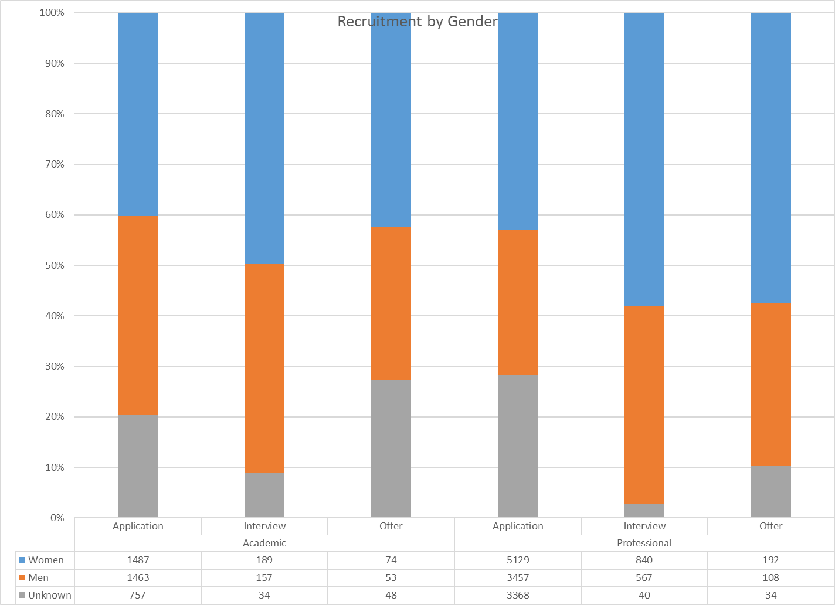

Overall the percentage of women applicants has increased from 41.1% in 2015/16 to 42.3% in 2018/19.
The proportion of women being shortlisted has increased from 54.6% in 2016/17 to 56.4% in 2018/19.

The table below shows the breakdown of applications by gender and the % that progress to the next stage.
Table 31 - Recruitment: Academic & Professional Services Staff by Gender & Stage 2016-2019
Academic | 2016/17 |  |  |  |  | 2017/18 |  |  |  |  | 2018/19
Academic | Women | % from previous Stage | Men | % from previous Stage | Other/ Unknown | Women | % from previous Stage | Men | % from previous Stage | Other/ Unknown | Women | % from previous Stage | Men | % from previous Stage | Other/Unknown
Research | 570 |  | 488 |  | 350 | 1058 |  | 553 |  | 519 | 930 |  | 604 |  | 476
Application | 474 |  | 400 |  | 350 | 890 |  | 467 |  | 516 | 790 |  | 504 |  | 402
Interview | 78 | 16.5% | 59 | 14.8% |  | 129 | 14.5% | 66 | 14.1% | * | 105 | 13.3% | 76 | 15.1% | 30
Offer | 18 | 23.1% | 29 | 49.2% |  | 39 | 30.2% | 20 | 30.3% | * | 35 | 33.3% | 24 | 31.6% | 44
Academic | 878 |  | 1220 |  | 427 | 863 |  | 1188 |  | 365 | 801 |  | 1034 |  | 354
Application | 757 |  | 1107 |  | 426 | 730 |  | 1031 |  | 363 | 682 |  | 927 |  | 348
Interview | 79 | 10.4% | 85 | 7.7% | * | 93 | 12.7% | 119 | 11.5% | * | 81 | 11.9% | 79 | 8.5% | *
Offer | 42 | 53.2% | 28 | 32.9% |  | 40 | 43.0% | 38 | 31.9% | * | 38 | 46.9% | 28 | 35.4% | *
Professor | 22 |  | 22 |  | 17 | 27 |  | 26 |  | 6 | 19 |  | 35 |  | 9
Application | 18 |  | 15 |  | 17 | 21 |  | 26 |  | * | 15 |  | 32 |  | 7
Interview | * | 16.7% | * | 33.3% |  | 6 | 29% |  | 0% |  | * | 20% | * | 6%
Offer | * | 33.3% | * | 40.0% |  |  | 0% |  | 0% | * | * | 33% | * | 50% | *
Professional
Clerical/Technical/Support/Other related | 4397 |  | 2867 |  | 2496 | 4794 |  | 3076 |  | 2369 | 4579 |  | 2834 |  | 2563
Application | 3783 |  | 2451 |  | 2484 | 4134 |  | 2610 |  | 2349 | 3844 |  | 2408 |  | 2525
Interview | 491 | 13.0% | 351 | 14.3% | 6 | 546 | 13.2% | 388 | 14.9% | 10 | 596 | 15.5% | 360 | 15.0% | 21
Offer | 123 | 25.1% | 65 | 18.5% | 6 | 114 | 20.9% | 78 | 20.1% | 10 | 139 | 23.3% | 66 | 18.3% | 17
SALC | 1240 |  | 1087 |  | 537 | 1256 |  | 981 |  | 669 | 1582 |  | 1298 |  | 879
Application | 984 |  | 864 |  | 517 | 1003 |  | 775 |  | 651 | 1285 |  | 1049 |  | 843
Interview | 195 | 19.8% | 186 | 21.5% | 11 | 197 | 19.6% | 171 | 22.1% | 10 | 244 | 19.0% | 207 | 19.7% | 19
Offer | 61 | 31.3% | 37 | 19.9% | 9 | 56 | 28% | 35 | 20% | 8 | 53 | 22% | 42 | 20% | 17

Recruitment Stage | Table 32 - BAME applicants at each stage of recruitment (%)
Recruitment Stage | 2016/17 | 2017/18 | 2018/19
Application | 35.9% | 36.5% | 37.7%
Interview | 37.8% | 38.3% | 39.9%
Appointment | 26.4% | 29.4% | 27.9%

Figure 7 – Recruitment by ethnicity -2017/18
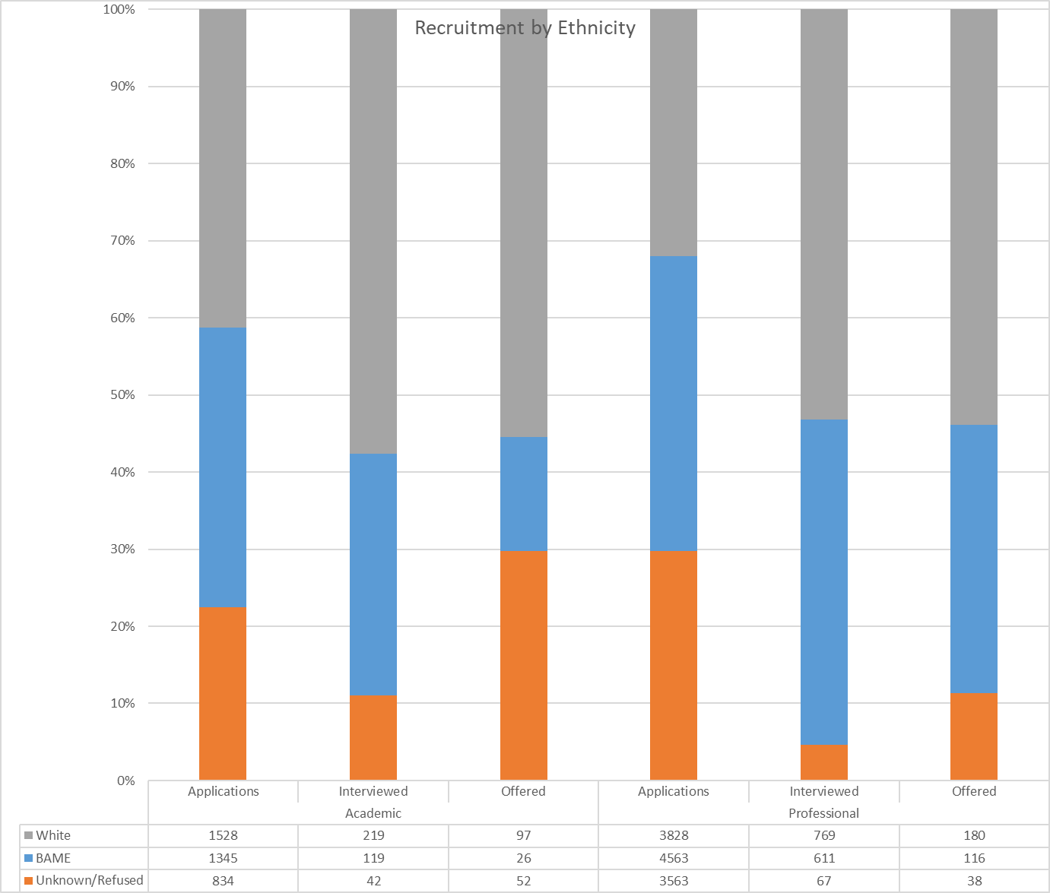
Overall the percentage of BAME applicants has increased from 35.9% in 2016/17 to 37.7% in 2018/19.
The proportion of those interviewed that were BAME was 39.9% in 2018/19, which has slightly increased since 2016/17, 37.8%. The proportion of appointments that were BAME was 27.9% in 2018/19 which is a decrease from 2017/18 (29.4%).
The table below shows the breakdown of applications by ethnicity and the % that progress to the next stage.
Table 33 - Recruitment: Academic and Professional Service Staff by Ethnicity & Stage (2016 - 2019)
 | 2016/17 |  |  |  |  | 2017/18 |  |  |  |  |  | 2018/19
 | BAME | % from previous Stage | White | % from previous Stage | Unknown/ Refused | BAME | % from previous Stage | White | % from previous Stage | Unknown/ Refused | BAME |  | % from previous Stage | White | % from previous Stage | Unknown/ Refused
Academic
Research | 493 |  | 527 |  | 377 | 688 |  | 882 |  | 549 | 720 |  |  | 785 |  | 505
Applications | 432 |  | 414 |  | 375 | 620 |  | 710 |  | 543 | 640 |  |  | 629 |  | 427
Interviewed | 49 | 11.3% | 85 | 20.5% | * | 55 | 8.9% | 127 | 17.9% | * | 65 |  | 10.2% | 113 | 18.0% | 33
Offered | 12 | 24.5% | 28 | 32.9% | * | 13 | 23.6% | 45 | 35.4% | * | 15 |  | 23.1% | 43 | 38.1% | 45
Academic | 609 |  | 1410 |  | 491 | 795 |  | 1195 |  | 423 | 752 |  |  | 1024 |  | 413
Applications | 576 |  | 1229 |  | 485 | 713 |  | 1000 |  | 411 | 690 |  |  | 868 |  | 399
Interviewed | 27 | 4.7% | 126 | 10.3% | * | 66 | 9.3% | 135 | 13.5% | 9 | 52 |  | 7.5% | 103 | 11.9% | 9
Offered | 6 | 22.2% | 55 | 43.7% | * | 16 | 24.2% | 60 | 44.4% | * | 10 |  | 19.2% | 53 | 51.5% | 5
Professor | 10 |  | 15 |  | 17 | 35 |  | 16 |  | 8 | 18 |  |  | 35 |  | 10
Applications | 10 |  | 13 |  | 17 | 30 |  | 15 |  | 7 | 15 |  |  | 31 |  | 8
Interviewed |  | 0.0% | * | 7.7% |  | * | 16.7% | 1 | 6.7% |  | * |  | 13.3% | * | 9.7%
Offered |  | 0.0% | * | 0.0% |  |  | 0.0% |  | 0.0% | * | * |  | 50.0% | * | 33.3% | *
Professional
Clerical/ Technical / Support | 3829 |  | 3258 |  | 2669 | 3979 |  | 3726 |  | 2529 | 3968 |  |  | 3281 | 720 | 2727
Applications | 3364 |  | 2717 |  | 2635 | 3484 |  | 3115 |  | 2493 | 3424 |  |  | 2684 | 720 | 2669
Interviewed | 391 | 11.6% | 435 | 16.0% | 22 | 404 | 11.6% | 511 | 16.4% | 25 | 458 |  | 13.4% | 481 | 17.9% | 38
Offered | 74 | 18.9% | 106 | 24.4% | 12 | 91 | 22.5% | 100 | 19.6% | 11 | 86 |  | 18.8% | 116 | 24.1% | 20
SALC | 989 |  | 1292 |  | 572 | 971 |  | 1227 |  | 705 | 1322 |  |  | 1496 | 720 | 941
Applications | 866 |  | 955 |  | 545 | 839 |  | 910 |  | 680 | 1139 |  |  | 1144 | 720 | 894
Interviewed | 111 | 12.8% | 261 | 27.3% | 18 | 111 | 13.2% | 249 | 27.4% | 15 | 153 |  | 13.4% | 288 | 25.2% | 29
Offered | 12 | 10.8% | 76 | 29.1% | 9 | 21 | 18.9% | 68 | 27.3% | 10 | 30 |  | 19.6% | 64 | 22.2% | 18

Table 34 - Disabled applicants at each stage of Recruitment - 2018/19
Disability | Applications | %* | Interviewed | %* | Hired | % Hired* | % Hired**
No Known Disability | 10710 | 68.3% | 1576 | 14.7% | 367 | 3.4% | 23.3%
Unknown | 4132 | 26.3% | 75 | 1.8% | 59 | 1.4% | 78.7%
Yes (GIS) | 462 | 2.9% | 110 | 23.8% | 10 | 2.2% | 9.1%
Yes (Not GIS) | 386 | 2.5% | 74 | 19.2% | 16 | 4.1% | 21.6%
Total | 15690 | 100.0% | 1835 | 11.2% | 452 | 2.4% | 21.5%
*of those that applied
**of those that were interviewed
5.4% of applicants disclosed a disability, with 2.9% of disabled applicants requesting to be considered under the Guaranteed Interview Scheme (GIS). It is also apparent that of those interviewed a higher proportion of disabled candidates not considered under GIS are hired (21.6%), compared to 9.1% of GIS applicants.

Section 9: Promotion and Progression
Table 35 – Gender: Academic and Professional Services Staff Progression: 2016-19
 | Women | Men | % Women | % Men
Academic | 76 | 67 | 53.1% | 46.9%
2016/17 | 32 | 20 | 62% | 38%
2017/18 | 20 | 23 | 46.5% | 53.5%
2018/19 | 24 | 24 | 50% | 50%
Professional Services | 132 | 97 | 57.6% | 42.4%
2016/17 | 55 | 41 | 57% | 43%
2017/18 | 45 | 33 | 57.7% | 42.3%
2018/19 | 32 | 23 | 58.2% | 41.8%
Total | 208 | 164 | 55.9% | 44.1%
NB: Promotion relates circumstances to Academic and Professional Service staff progression from one grade to another (unless it is automatic) and the formal academic promotion process. There is no formal promotion process for promotions for PSS; progression to a higher grade is through re-evaluation of the grade for the role or a recruitment application to a higher graded post.
For both Academic and PSS staff an equal or higher proportion of women were promoted or progressed in 2018/19.
Table 36 - Ethnicity: Academic and Professional Services Staff - 2016-2019
 | BAME | White | Refused/ Not Known | BAME %
Academic | 26 | 115 | * | 18.4%
2016/17 | 12 | 40 |  | 23.1%
2017/18 | 8 | 34 | * | 19.0%
2018/19 | 6 | 41 | * | 13%
Professional Services | 75 | 150 | * | 33.3%
2016/17 | 29 | 66 | * | 30.5%
2017/18 | 29 | 47 | * | 38.2%
2018/19 | 17 | 37 | * | 31.5%
Total | 101 | 265 | 6 | 27.6%
*Calculations include only those who have disclosed their ethnicity.
In 2018/19, 13% of academics promoted were BAME staff which is lower than City’s academic BAME population (17%) and for PSS 31.5% of staff that progressed were BAME, which is also lower than the PSS BAME population in 2018/19, 32.9%.

Table 37: Disability: Academic & Professional Service Staff Progression - 2018/19
 | Disability | No known Disability | Not known/refused | % with Disability
Academic | * | 42 | * | 8.3%
Professional Services | * | 51 | * | 3.6%
Total | 6 | 93 | * | 5.8%
*% Disability of those who progressed measured against all those who progressed within Academic and Professional Services respectively.
For academic staff 8.3% of those promoted had disclosed a disability in 2018/19, and 3.6% of PSS who were promoted/progressed to a higher grade.

Section 10: Training opportunities
Training data relates to all salaried staff who attended classroom training in the academic year that was organised by either Organisational Development or the Health & Safety team. Training events generally fit into the category of career progression, equality, health & safety, management & personal development. For example; Successful proposals for EU Funding, Diversity Awareness, Building Disability Confidence, Department Safety Officer training, UKVI compliance and visa checking, coaching sessions and corporate inductions.
Table 38 - Training by Gender: 2016-2019
 | Women |  |  | Men
 | Headcount | Attended | % | Headcount | Attended | %
2016/17 | 1143 | 459 | 40% | 1124 | 283 | 25%
Academic | 418 | 85 | 20% | 556 | 74 | 13%
Professional | 725 | 374 | 52% | 568 | 209 | 37%
2017/18 | 1203 | 512 | 42.6% | 1144 | 338 | 29.5%
Academic | 450 | 106 | 24% | 553 | 93 | 17%
Professional | 753 | 406 | 54% | 591 | 245 | 41%
2018/19 | 1136 | 559 | 49.2% | 1038 | 291 | 28.0%
Academic | 496 | 112 | 23% | 580 | 105 | 18%
Professional | 817 | 447 | 55% | 600 | 186 | 31%
* 2015-2018 'Headcount' reflects headcount over the year
The proportion of women attending training in 2018/19 was 49.2%, this is an increase from 42.6% in 2017/18. It should be noted that a higher proportion of women attend training than men, 49.8% of women, compared to 28% of men.
Table 39 - Training - Grade 9 Staff: 2016-2019
 | Women |  |  | Men
 | Headcount | Attended | % | Headcount | Attended | %
2016/17 | 66 | 20 | 30% | 202 | 39 | 19%
Professor | 50 | 15 | 30% | 174 | 27 | 16%
Senior Admin | 16 | * | 31% | 28 | 12 | 43%
2017/18 | 73 | 23 | 31.5% | 196 | 34 | 17.3%
Professor | 55 | 14 | 25.5% | 170 | 28 | 16.5%
Senior Admin | 18 | 9 | 50.0% | 26 | 6 | 23.1%
2018/19 | 76 | 17 | 22.4% | 191 | 23 | 12%
Professor | 59 | 13 | 22% | 167 | 21 | 12.6%
Senior Admin | 17 | * | 23.5% | 24 | * | 8.3%
*2016-2019 ‘Headcount’ reflects headcount over the year
Of our professors and senior administrative staff groups, women were also more likely to attend training than men, 22.4% of women, compared to 12% of men in 2018/19. The proportion of men professors and senior administrative staff attending training has decreased from 19% in 2016/17 to 12% in 2018/19.

Table 40 - Training by Ethnicity 2016-2019
 | BAME |  |  | Refused/Not known |  |  | White
 | Headcount | Attended | % | Headcount | Attended | % | Headcount | Attended | %
2016/17 | 545 | 198 | 36% | 49 | 14 | 29% | 1673 | 530 | 32%
Academic | 169 | 24 | 14% | 22 | * | 18% | 783 | 131 | 17%
Professional | 376 | 174 | 46% | 27 | 10 | 37% | 890 | 399 | 45%
2017/18 | 581 | 235 | 40% | 54 | 15 | 28% | 1712 | 600 | 35%
Academic | 170 | 32 | 19% | 25 | * | 16% | 808 | 163 | 20%
Professional | 411 | 203 | 49% | 29 | 11 | 38% | 904 | 437 | 48%
2018/19 | 554 | 253 | 40% | 51 | 19 | 28% | 1569 | 578 | 35%
Academic | 186 | 41 | 22% | 28 | 5 | 18% | 862 | 171 | 20%
Professional | 451 | 212 | 47% | 31 | 14 | 45% | 935 | 407 | 44%
*2016-2019 ‘Headcount’ reflects headcount over the year
In 2018/19, 40% of BAME staff attended training which was slightly higher than the proportion of White staff attending training, 35%. These are the same figures as reported in the previous year, 2017/18.
A much higher proportion of BAME PSS attended training, 47%, than BAME academic staff, 22% in 2018/19.
Table 41 - Training by Age Range 2016-2019
 | Women |  |  | Men
 | Headcount | Attended | % | Headcount | Attended | %
2016/17 | 1143 | 459 | 40% | 1124 | 283 | 25%
Under 25 | 44 | 28 | 64% | 32 | 11 | 34%
25 - 34 | 337 | 163 | 48% | 270 | 94 | 35%
35 - 44 | 359 | 147 | 41% | 335 | 78 | 23%
45 - 54 | 252 | 78 | 31% | 264 | 64 | 24%
55 - 64 | 133 | 42 | 32% | 157 | 31 | 20%
65+ | 18 | * | 6% | 66 | * | 8%
2017/18 | 1203 | 512 | 43% | 1144 | 338 | 30%
Under 25 | 37 | 12 | 32% | 30 | 14 | 47%
25 - 34 | 358 | 192 | 54% | 288 | 106 | 37%
35 - 44 | 391 | 161 | 41% | 315 | 93 | 30%
45 - 54 | 256 | 97 | 38% | 269 | 67 | 25%
55 - 64 | 139 | 45 | 32% | 171 | 54 | 32%
65+ | 22 | * | 23% | 71 | * | 6%
2018/19 | 1136 | 559 | 49% | 1038 | 291 | 28%
Under 25 | 47 | 19 | 40% | 27 | 9 | 33%
25 - 34 | 397 | 205 | 52% | 279 | 89 | 32%
35 - 44 | 403 | 169 | 42% | 336 | 104 | 31%
45 - 54 | 289 | 106 | 37% | 283 | 49 | 17%
55 - 64 | 151 | 53 | 35% | 190 | 38 | 20%
65+ | 26 | 7 | 27% | 65 | * | 3%
*2016-2019 ‘Headcount’ reflects headcount over the year
The number of staff attending training varies by age group. For both men and women, staff aged 25-34 had the largest proportion of staff attending training.

Table 42 - Training by Disability Disclosure 2016-2019
 | Information refused |  |  | None |  |  | Not Known |  |  | Disabled
 | Headcount | Attended | % | Headcount | Attended | % | Headcount | Attended | % | Headcount | Attended | %
2016/17 | 19 | * | 10.5% | 1885 | 638 | 33.8% | 259 | 66 | 25.5% | 104 | 36 | 34.6%
Academic | 11 |  | 0% | 796 | 132 | 17% | 123 | 15 | 12.2% | 44 | 12 | 27.3%
Professional | 8 | * | 25% | 1089 | 506 | 46% | 136 | 51 | 37.5% | 60 | 24 | 40%
2017/18 | 23 | 7 | 30.4% | 1975 | 736 | 37.3% | 232 | 60 | 25.9% | 117 | 47 | 40.2%
Academic | 11 | * | 27.3% | 826 | 164 | 19.9% | 113 | 18 | 15.9% | 53 | 14 | 26.4%
Professional | 12 | * | 33.3% | 1149 | 572 | 49.8% | 119 | 42 | 35.3% | 64 | 33 | 51.6%
2018/19 | 30 | 11 | 36.7% | 2119 | 741 | 35.0% | 214 | 42 | 19.6% | 130 | 56 | 43.1%
Academic | 13 | * | 23.1% | 903 | 181 | 20.0% | 104 | 16 | 15.4% | 56 | 17 | 30.4%
Professional | 17 | 8 | 47.1% | 1216 | 560 | 46.1% | 110 | 26 | 23.6% | 74 | 39 | 52.7%
In 2018/19 43.1% of staff who disclosed a disability attended training. This proportion and number of disabled staff attending training has increased from 34.6% in 2017/18.
Students’ Equality Monitoring Statistics 2018/19

The following report provides an overview of student equality data at City, with both analysis of the institution overall, and of data within each of City’s Schools. The following protected characteristics are considered in the analysis provided through this report:
- Age
- Disability
- Ethnicity
- Gender (Sex)

City also collects data on Religion and Belief, Sexual Orientation and Gender Identity for students, although the data collected are not reported here due to the quality of the data and the uptake of disclosure. This data collection has been in place since 2017/18.

It should be noted that the data used within this report to calculate student headcount comprises City’s full headcount without exclusions based on student status, meaning that numbers will differ from those included in other reports available on the City website. Including all students without exclusions allows us to give a fuller snapshot of our registered student population.

Other similar City reports have been calculated using the Higher Education Statistics Agency (HESA) methodology of standardised exclusions (excluding, for example, dormant students, writing-up students, and visiting students, etc.).

* Denotes a number which is less than 10.

The following acronyms have been used within this report for each of City’s Schools.

School | Acronym
Cass Business School | Cass
City Law School | CLS
Learning Enhancement and Development | LEaD
School of Arts and Social Sciences | SASS
School of Health Sciences | SHS
School of Mathematics, Computer Science and Engineering | SMCSE

- Overview of Student Body

Student Body Overview
There has been a significant increase to City’s overall student population between 2017/18 and 2018/19, with student headcount increasing by 14.71%. The increase for FTE has been more gradual at 2.24%.

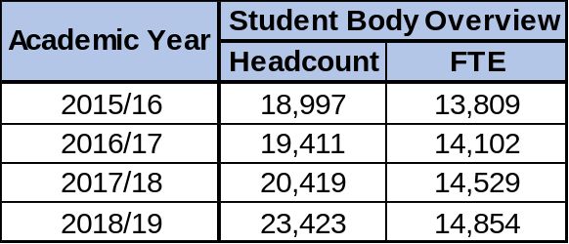

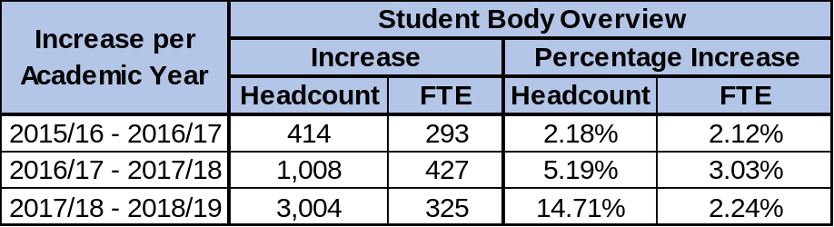

Student Body Mode of Study
The proportion of City’s students studying part-time has increased by 8.2% between 2017/18 and 2018/19, meaning that over one quarter of City students are now on a part-time programme of study.

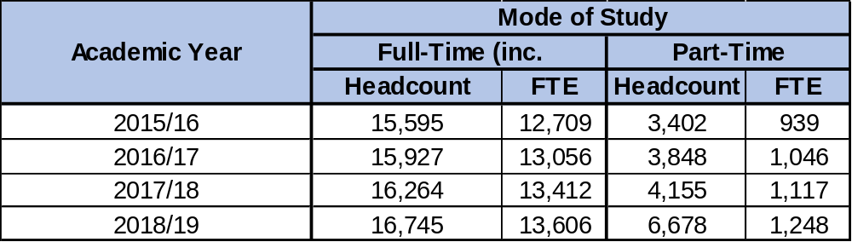

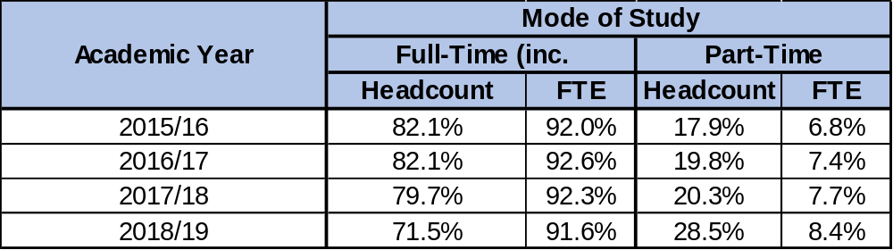

School Populations
A partial increase in student numbers, ranging from an additional 97 students in LEaD to an increase of over 1200 students in SHS, has taken place across all Schools from 2017/18 to 2018/19.

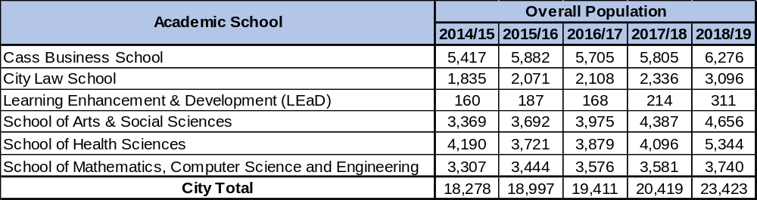

Cass still accounts for the largest proportion of City students at 26.8% (slightly less than in 2017/18), followed by SHS. LEaD accounts for the smallest proportion of City students at just 1.3%.

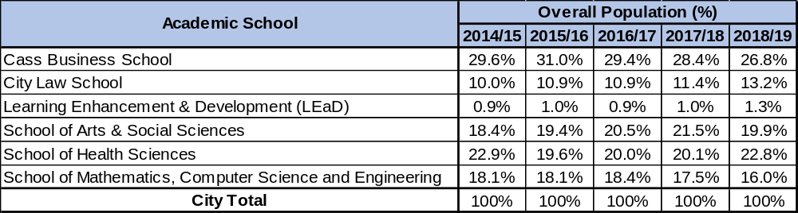

Level of Study Breakdown by School and City Overall
The greatest proportion of City students are consistently undergraduate students studying their First Degree.
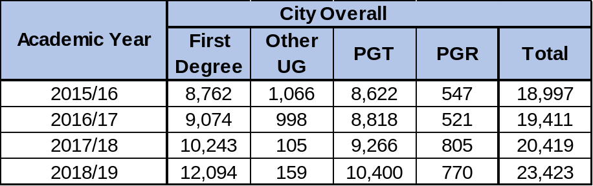

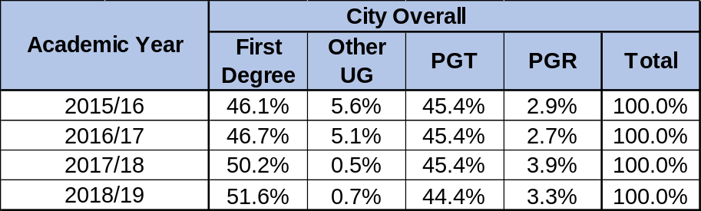

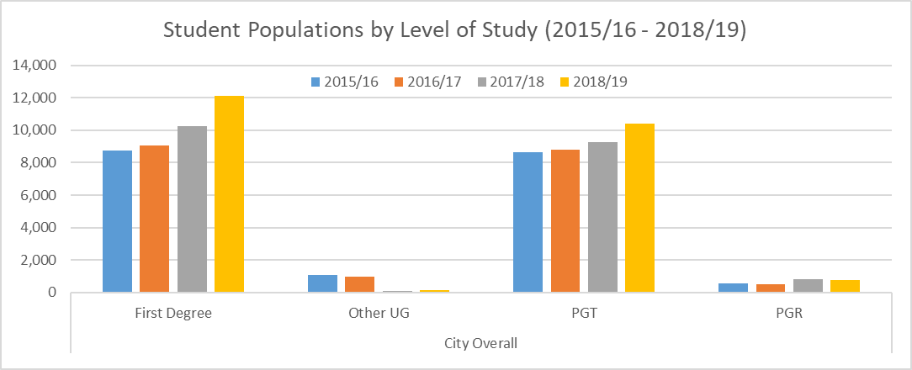
The proportion of postgraduate taught students has been consistent across 2015/16 to 2017/18, but has reduced slightly for the first time in 2018/19 as the proportion of undergraduate First Degree students has increased. The proportion of students undertaking an ‘Other undergraduate degree’ is also much lower than in previous years for the second year in a row.
Cass numbers have increased generally across all groups. Cass is the only School to have a majority of postgraduate taught students at City.

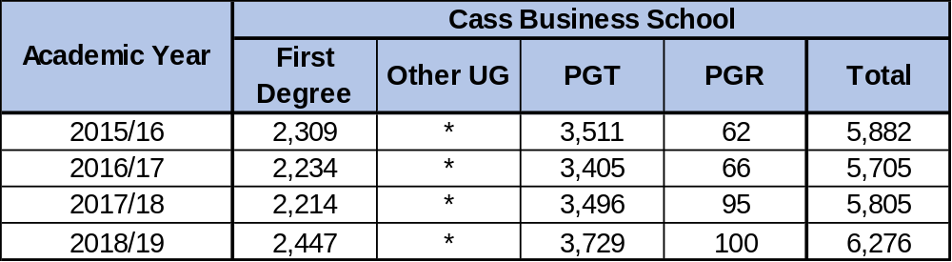

City Law School has experienced a considerable increase in the number of postgraduate taught students, which has more than doubled since 2015/16.

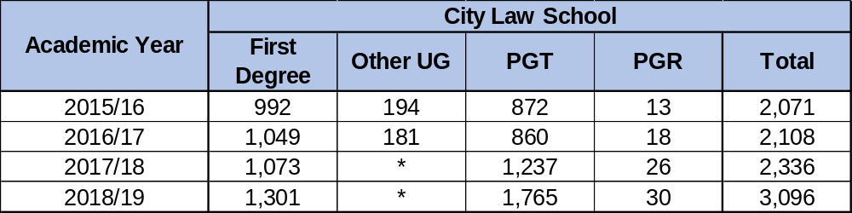

LEaD principally delivers a postgraduate taught programme, and have a small number of students on a postgraduate research programme. Student numbers have increased steadily since 2016/17.

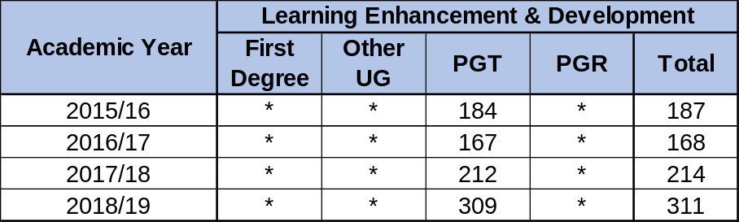

SASS has seen a slight decrease in the number of postgraduate taught and postgraduate research students since 2017/18, and an increase in the number of undergraduate students.

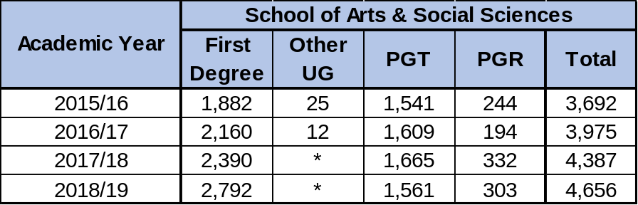

SHS has the highest numbers of students on an ‘other undergraduate’ degree of any of the Schools. There has been a significant increase in the number of undergraduate students between 2017/18 and 2018/19, with around a thousand extra undergraduate students accounted for each year since 2016/17 onwards.

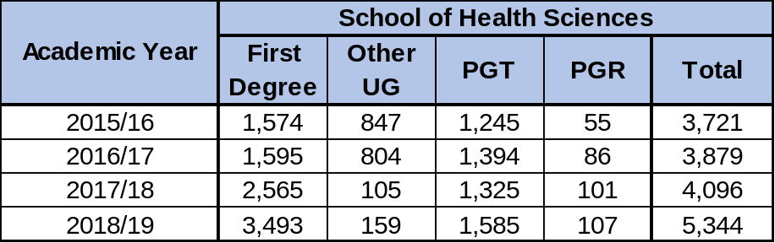

SMCSE has the most consistent year-on-year numbers of any of the Schools.

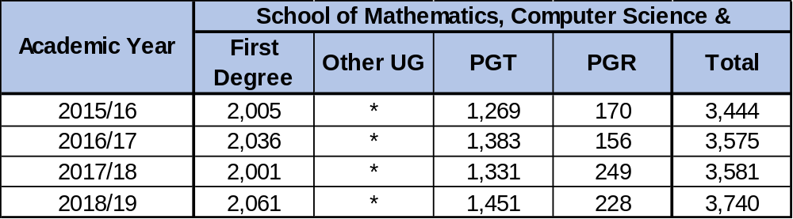

- Age

The greatest proportion of students at City overall continues to be students aged between 21 and 24 years old, followed by students aged over 30 years old. All groups other than ‘Under 18’ have seen an increase since the 2017/18 academic year, and all groups have seen an increase in student numbers since 2015/16, other than 18 – 20-year olds, which has accounted for a considerably reduced proportion of City students since 2017/18, now accounting for approximately half of the proportion it accounted for previously.

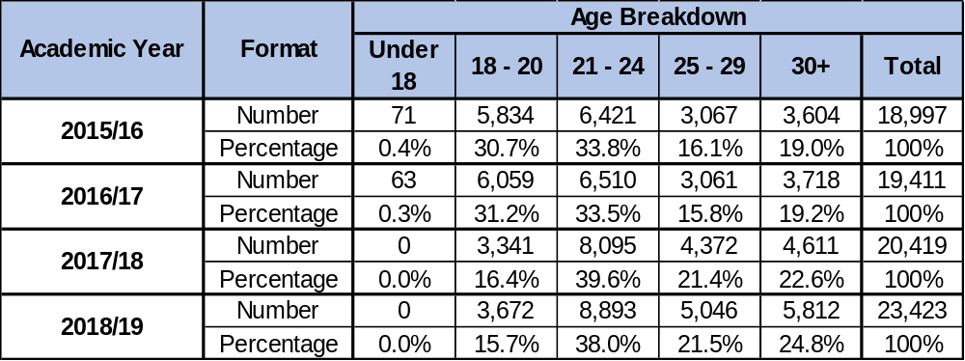

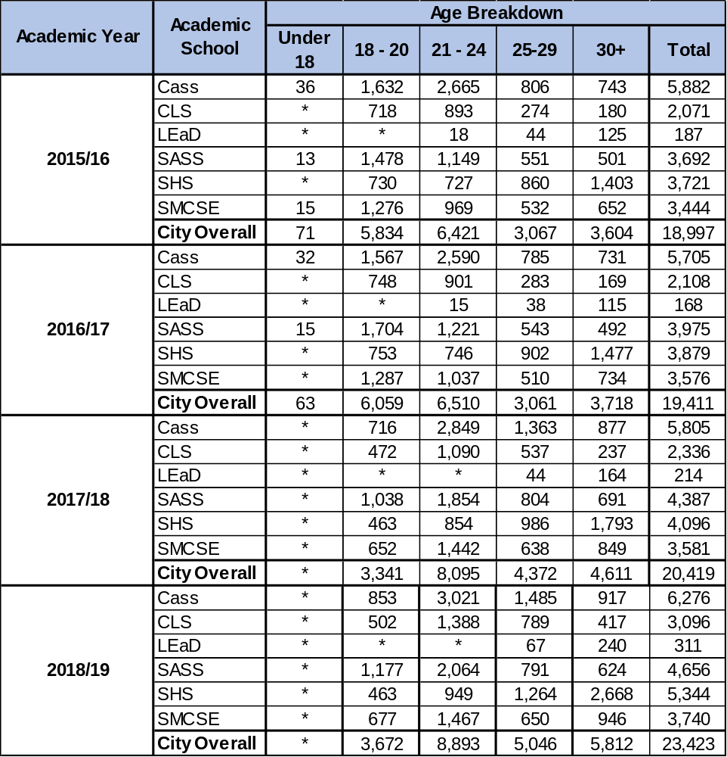

The above table provides a breakdown of age group by School across the period 2015/16 – 2018/19. These numbers are presented as proportions of overall populations on the following pages, but from the numbers presented here it is clear that the average age of City’s students has risen across the time period, with a higher number of students in the older age groups, and fewer students aged 18 – 20.

Since 2017/18, City has had no registered students aged under 18.

This is against a national picture, based on the Advance HE Student Statistical Report 2019, which has seen an increase in the representation of students aged 21 and under (rising from 57.5% in 2015/16 to 57.0% in 2017/18), while groups of more mature students have seen a reduction in size.
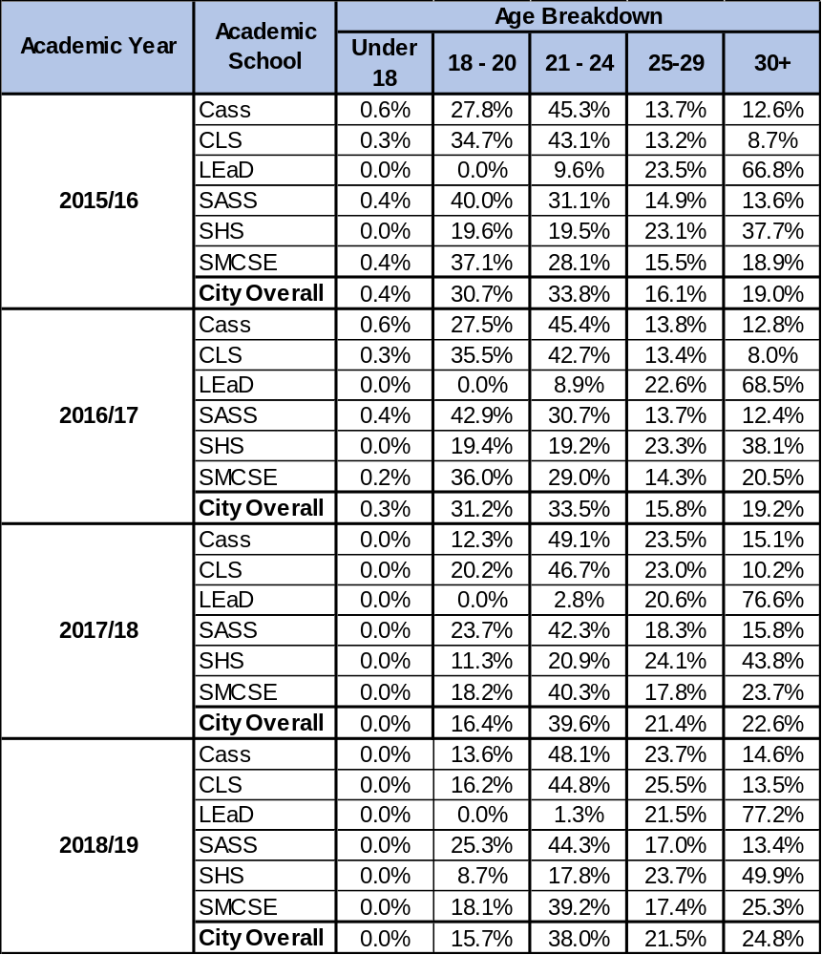

One of the most marked changes in the last few years has been in the increase of students in the 25 – 29 age group within Cass, where this has risen from 13.8% in 2015/16 to 23.5% in 2017/18, and then at 23.7% in 2018/19. This was mirrored by a reduction in students aged 18 – 20 across the period, falling from 27.8% to 13.6%.

While SMCSE and SASS have seen a considerable increase in the proportion of students in the 21 – 24 age bracket (rising from 28.1% in 2015/16 to 39.2% in 2018/19), LEaD have experienced a gradual reduction in students in this age bracket (falling from 9.6% in 2015/16 to 1.3% in 2018/19) and the proportion of Cass, CLS and SHS students in this bracket have remained relatively consistent (Cass: 45.3% in 2015/16 and 48.1% in 2018/19; CLS: 43.1% in 2015/16 and 44.8% in 2018/19; SHS: 19.5% in 2015/16 and 17.8% in 2018/19).

In 2018/19, SASS has the highest proportion of students in the 18 – 20 age group (25.3%), which was also true in 2015/16 (40.0%). Cass has the highest proportion of students in the 21 – 24 age group (48.1%), which was also true in 2015/16 (45.3%). CLS has the highest proportion of 25 – 29-year olds in 2018/19 (25.5%), while this had been LEaD in 2015/16 (23.5%) and SHS when focusing on the larger Schools (23.1%). LEaD has the highest proportion of students in the 30+ group in 2018/19 (77.2%), and SHS when focusing on the larger Schools (49.9%), which was also true in 2015/16 when 66.8% of LEaD students and 37.7% of SHS students were in this group.

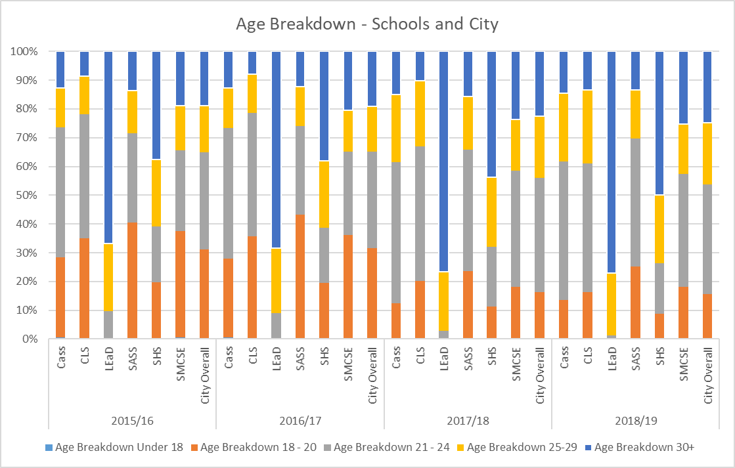

- Disability

The proportion of students with a disclosed disability has grown steadily across the four-year period, rising from 5.4% in 2015/16 to 7.4% in 2018/19. This is still considerably lower than the national average, as Advance HE report that, according to the most recently available data, 12.9% of students nationally disclose a disability.

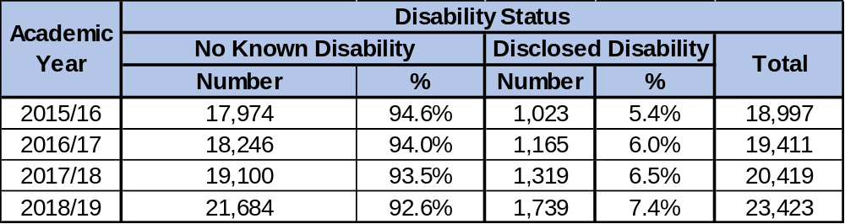

2017/18 to 2018/19 has seen the most considerable increase in the number and proportion of disabled students at City in recent years, with an additional 420 students having disclosed a disability, accounting for a 0.9% increase between the two academic years.

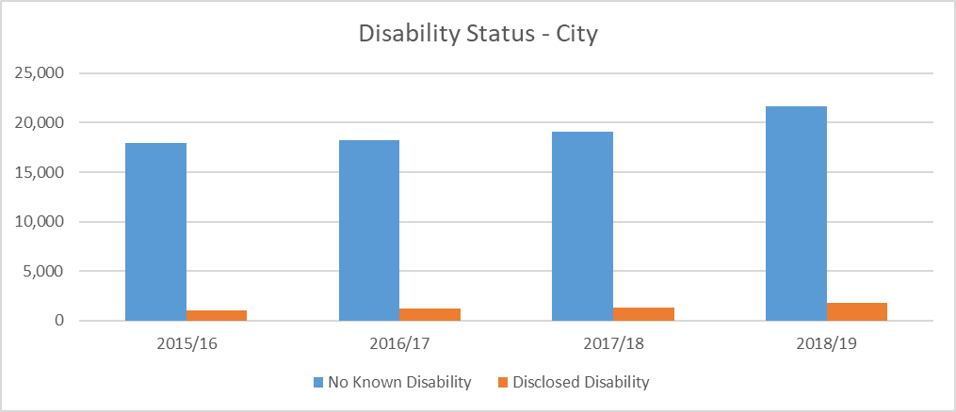

City’s representation of disabled students is still considerably below the national average, and through City’s Access and Participation Plan 2020/21 – 2024/25, further data will continue to be analysed in order to attempt to better understand the reasons for this (e.g. whether disabled students are not accessing City, or whether they are not disclosing their disability to the university).

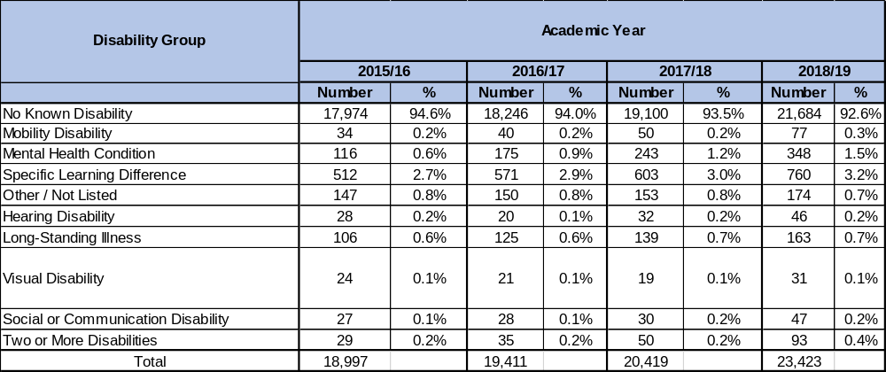
The impact of the Integrated Student Support Review (2019) and the reorganisation of Student and Academic Services and LEaD which has resulted in the formation of Student Counselling, Mental Health and Accessibility Services, may also have a longer-term impact on the disclosure rates and representation of disabled students at City.

In 2018/19, as in previous years, the most highly represented disability group has been students who report a Specific Learning Condition (SpLD), which accounts for 3.2% of City’s students. This is followed by students reporting a Mental Health Condition, which accounts for 1.5% of City students. Students with a Visual Disability account for the smallest proportion of the City population, at just 0.1%.
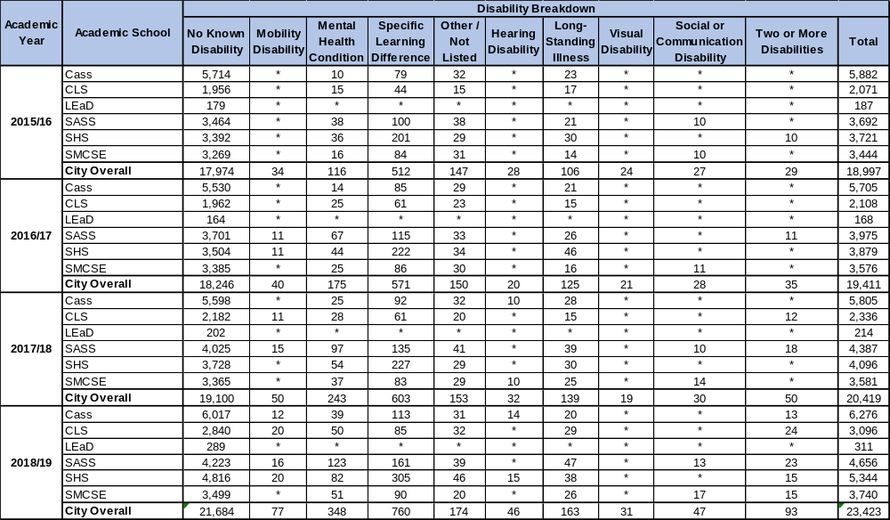

The numbers of students reporting a disability in each group have increased, in some cases quite considerably, from 2015/16 to 2018/19 for City overall. No group has experienced a reduction in size for the overall university during this time period.
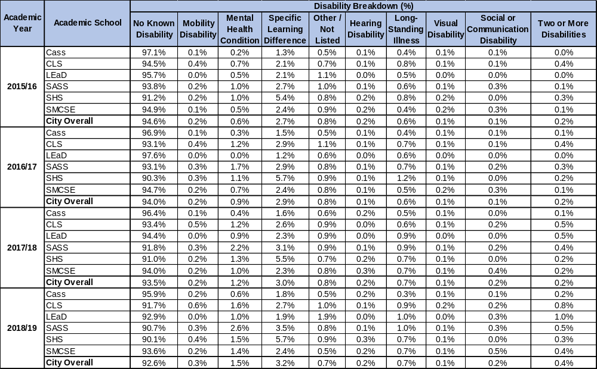
Cass has continuously had the highest proportion of students with No Known Disability across the period, although this has fallen slightly from 97.1% (2015/16) to 95.9% (2018/19). Conversely, SHS have continuously had the highest proportion of students to have disclosed a disability across the period which has increased slightly from 8.8% (2015/16) to 9.9% (2018/19).

SHS also account for the highest proportion of students who have disclosed an SpLD, which was 5.4% in 2015/16 and 5.7% in 2018/19, while SASS account for the highest proportion of students to disclose a Mental Health Condition, which was 1.0% in 2015/16 (joint with SHS) and 2.6% in 2018/19.

- Ethnicity

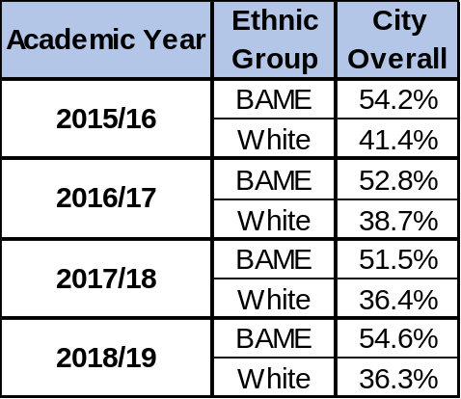
BAME refers to students who identify as an ethnicity which can be categorised into the Black, Asian or Minority Ethnic group.

BAME students account for 54.6% in 2018/19, the highest proportion across the four-year period (BAME students had accounted for 54.2% of students in 2015/16).

In 2018/19, White students account for 36.3% of City’s students (the lowest proportion in the period), and students in the Not Known / Refused group accounted for 9.2% of City’s students.

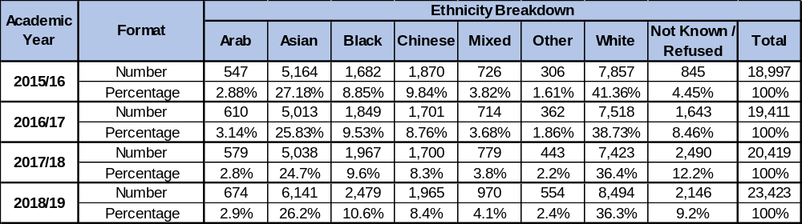
According to Advance HE, in 2017/18, 23.6% of UK-domiciled students were BAME. For City in 2018/19, BAME students accounted for 54.6% of our overall student population, 58.7% of our UK-domiciled students, and 46.5% of our Non-UK-domiciled students.
White students, as a distinct ethnic group, continually account for the highest proportion of City’s students within the four-year period, although this has gradually reduced across the period from 41.36% (2015/16) to 36.3% (2018/19).

The proportion of students identifying themselves into the Not Known / Refused group, which accounts for students who select either ‘I don’t know’ or ‘Prefer not to say’, has increased across the four-year period, rising to 9.2% (2018/19) from 4.45% in 2015/16, but has fallen since 2017/18 when this was 12.2%.

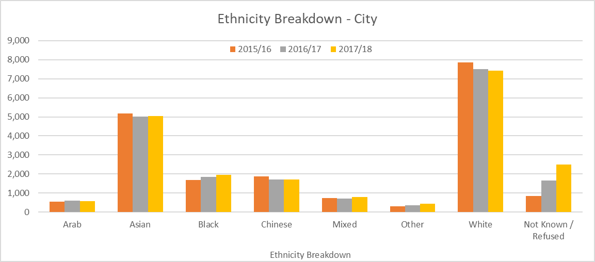
The proportion of Black students has increased consistently across the four-year period, rising from 8.85% in 2015/16 to 10.6% in 2018/19. This has been the most considerable growth experienced by any ethnic group, while Mixed students and Other students have each seen a smaller increase in their representation.

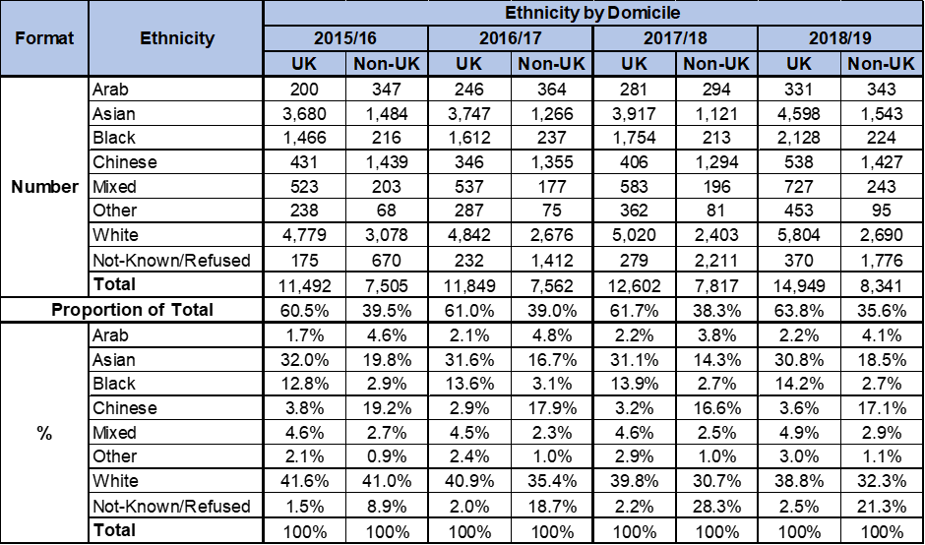
The proportion of Asian students has fallen very slightly across the period, reaching 26.2% in 2018/19, from 27.18% in 2015/16. This group, however, remains the largest at City out of the BAME population.

In 2018/19, White students accounted for the highest proportion of both UK-domiciled and Non-UK-domiciled students at City (UK at 38.8% and Non-UK at 32.3%), followed by Asian students who accounted for 30.8% of UK-domiciled students and 18.5% of Non-UK-domiciled students. Chinese students have consistently accounted for a significant proportion of Non-UK-domiciled students, ranging from 16.6% (2017/18) to 19.2% (2015/16) across the period.

The proportion of Non-UK-domiciled students identifying into the Not Known / Refused group has increased considerably, rising from 8.9% in 2015/16 to 21.3% in 2018/19, but peaking at 28.3% in 2017/18.

City’s proportion of UK-domiciled students has increased slightly across the four-year period, rising from 60.5% in 2015/16 to 63.8% in 2018/19.
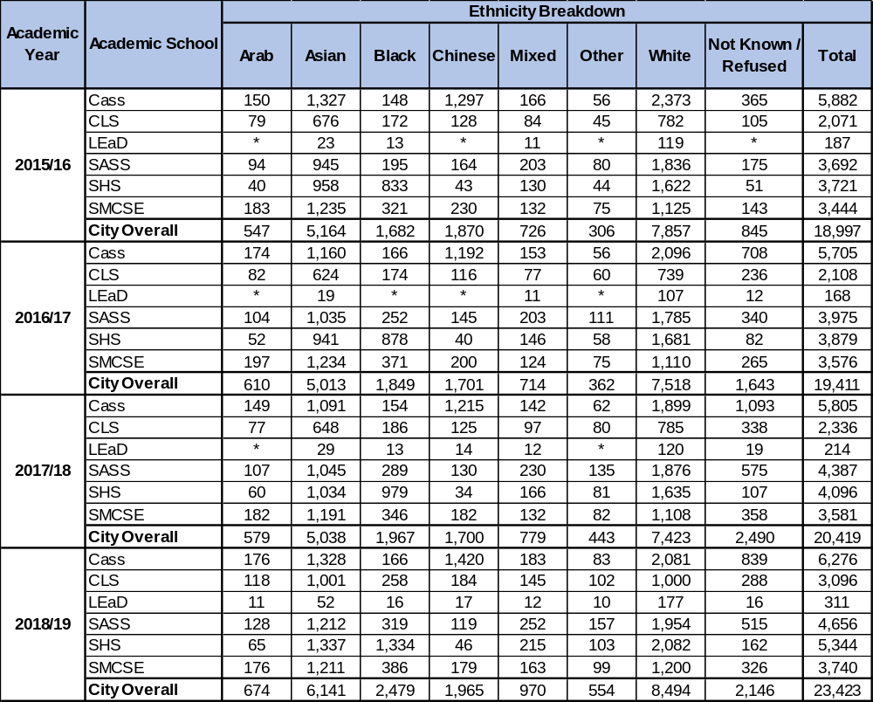

All ethnic groups have seen an increase in their numbers between 2015/16 and 2018/29. Notably, the ethnic diversity has increased within LEaD across the four-year period to the point that numbers for all ethnic groups in LEaD are now high enough to be reported within this report. LEaD’s proportion of White students, which remains the highest of any School, has fallen from 63.6% in 2015/16 to 56.9% in 2018/19.

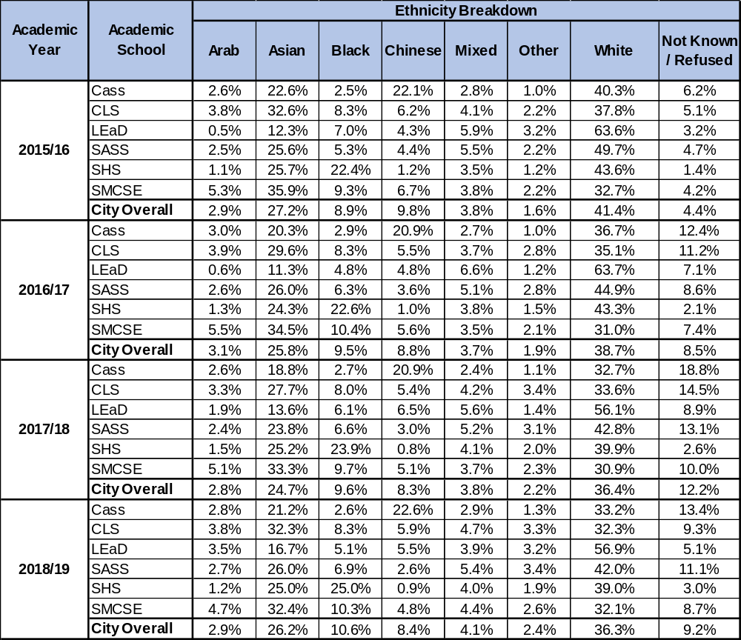
SMCSE has consistently had the highest proportion of Arab students at City, although this has reduced slightly from 5.3% (2015/16) to 4.7% (2018/19). SMCSE also has the highest proportion of Asian students, which was 32.4% in 2018/19, and followed very closely by CLS at 32.3%.

SHS has consistently had the highest proportion of Black students at City, which has increased from 22.4% in 2015/16 to 25.0% in 2018/19. SHS also had 25.0% Asian students in the same year. Cass consistently has the highest proportion of Chinese students, accounting for 22.1% in 2015/16 and rising very slightly to 22.6% in 2018/19, while SHS has the smallest proportion of Chinese students, which has fallen from 1.2% in 2015/16 to 0.9% in 2018/19.

Mixed students are fairly consistently represented across all Schools, although LEaD had the highest representation in 2015/16 at 5.9%. In 2018/19, SASS had the highest proportion of Mixed students, at 5.4%. Cass has consistently had the lowest proportion of Mixed students, which has increased from 2.8% to just 2.9% across the four-year period.

Other students were most highly represented in LEaD in 2015/16, at 3.2%, while in 2018/19, SASS had the highest proportion of this group, at 3.4%.

LEaD has consistently had the greatest proportion of White students across the period. However, of the larger Schools, SASS have had the highest proportion of White students, although this has fallen from 49.7% in 2015/16 to 42.0% in 2018/19.

Cass has consistently had the highest proportion of students in the Not Known / Refused group, accounting for 6.2% of Cass students in 2015/16 and 13.4% in 2018/19.

- Gender (Sex)

City remains a majority women university, with 58.2% of students identifying as women in 2018/19. This represents a slight increase across the four-year period, as this has risen from 55.9% in 2015/16.

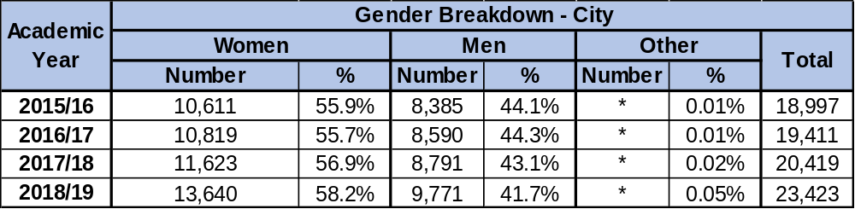

The proportion of men has fallen slightly across the four-year period, from 44.1% in 2015/16 to 41.7% in 2018/19. The proportion of students who have selected Other has increased from 0.01% in 2015/16 to 0.05% in 2018/19.

City is only very marginally out of line with national statistics, as Advance HE report that UK universities had 57.0% women students and 43.0% men in 2017/18.

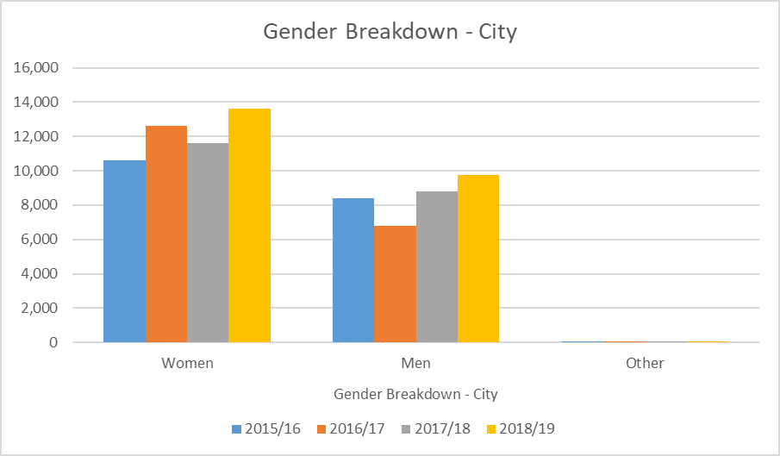
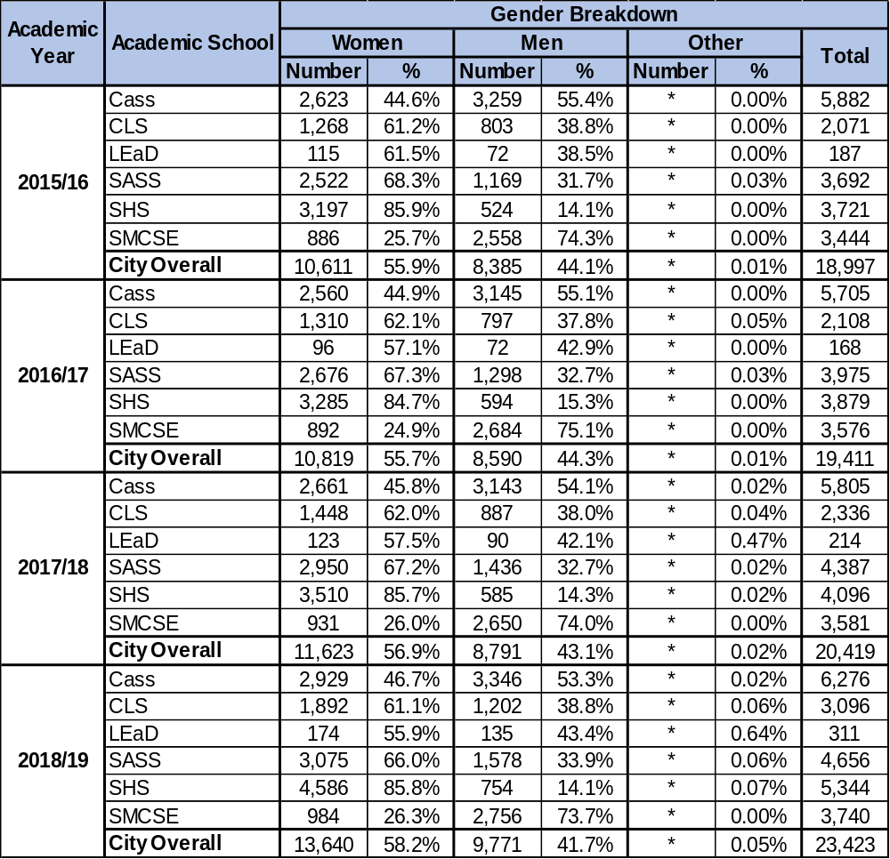

SHS has consistently had the highest proportion of women of any School at City across the four-year period, which has stayed fairly level, starting at 85.9% in 2015/16 and falling marginally to 85.8% in 2018/19. CLS and SASS also each have consistently had more than 60% women students across the period.

SMCSE has the highest proportion of men at City, which has fallen slightly from 74.3% in 2015/16 to 73.7% in 2018/19. Cass has consistently had the second-highest proportion of men, ranging from 55.4% in 2015/16 to 53.3% in 2018/19.

In 2018/19, SHS had the highest proportion and number of students who had identified as Other, while SMCSE had the lowest.

Advance HE Student Statistical Report 2019; https://www.advance-he.ac.uk/knowledge-hub/equality-higher-education-statistical-report-2019, p. 42.
Advance HE Statistical Report 2019, p. 76.
City’s Access and Participation Plan 2020/21 – 2024/25; https://www.city.ac.uk/about/governance/legal/office-for-students-ofs
Advance HE Statistical Report 2019, p. 111.
Advance HE Statistical Report 2019, p. 145.

