Transparency and controllability in user interfaces that adapt during run-time

Matthias Peissner
Fraunhofer IAO
Nobelstr. 12
70569 Stuttgart, Germany
+49 711 970 2311
matthias.peissner@iao.fraunhofer.de
Thomas Sellner
Fraunhofer IAO
Nobelstr. 12
70569 Stuttgart, Germany
+49 711 970 2347
thomas.sellner@iao.fraunhofer.de

ABSTRACT
This position paper presents research issues and solutions from the current European research project MyUI. MyUI provides a framework and a technical infrastructure for adaptive user interfaces to increase the accessibility of ICT products. After an introduction of the MyUI approach which relies on the run-time composition of design patterns, we highlight our contribution to increasing the transparency and controllability of self-adaptive user interfaces. Two dedicated categories of MyUI design patterns have been developed: (1) Adaptation Rendering Patterns describe solutions for transparent transitions by animations; (2) Adaptation Dialogue Patterns cover dialogue strategies to put the user into control of the system-initiated adaptations. A current user study evaluates the effectiveness of the proposed patterns. The results will be available before the workshop.

Keywords
Adaptive user interfaces, design patterns, transparency, controllability, accessibility

INTRODUCTION
Self-learning and self-adaptive user interfaces offer great opportunities for accessibility and improved usability for a broad range of diverse users. However, they also pose significant challenges in terms of usability, trustworthiness and acceptability. Consistency is a main quality of usable and reliable user interfaces. System-initiated adaptations will lead to changes in the appearance of the user interface. In many cases, adaptations will occur in situations of interaction problems. Therefore, it is important that changes triggered by adaptation processes do not lead to further disorientation but support the user in recovering from an experienced interaction problem. A second important topic for user interface adaptations is their transparency. The users must be able to recognize changes in the user interface and they should also be able to understand why the change has been made. Finally, intelligent and automatic adaptations must not lead to situations where the end user feels like losing control over the user interface.
MyUI recognizes that the design of the adaptation process is a major issue for the usability and acceptability of adaptive user interfaces. MyUI addresses this important field with dedicated Adaptation Patterns. They inform the users about intended or ongoing adaptations, and provide the users with effective control mechanisms. This paper is structured as follows: the next section provides a short summary of some related work. Then, the overall MyUI system is introduced. In the main part, we describe the MyUI adaptation patterns which aim at increasing the transparency and controllability. Finally, a user study for evaluating the proposed solutions is outlined and open research issues are summarized.

RELATED WORK
For the personalization of user interfaces, mainly two approaches exist. Adaptable user interfaces provide the user with mechanisms to actively customize the interface, whereas adaptive user interfaces initiate and perform dynamic adjustments autonomously (cf. [4], [9]).
Both approaches have their pros and cons. The most important advantage of adaptable systems is that the users are in total control of the individual appearance of their user interface. This supports the understandability and traceability of modifications from the user’s perspective (cf. [7]). However, this advantage is at the same the main a shortcoming of adaptable user interfaces – especially when personalization aims at increasing the accessibility. Users with disabilities and lower levels of ICT literacy would benefit most from personalized user interfaces. They often have severe problems with standard configurations. Customization dialogues, however, are a significant barrier - even for abled users [10].
On the other hand, adaptive user interfaces are often blamed for confusing the users with unpredictable adaptation behaviors which cannot be understood nor controlled by the users [14]. Mechanisms to overcome the lacks of transparency and controllability in adaptive user interfaces have received relatively little attention in the literature. In a recent paper, Dessart et al. describe a first attempt to improving the transparency of run-time adaptations by animated transitions. They propose a taxonomy of adaptation categories and suitable transitions [3]. For the problem of controllability, not much specific guidance is available. Findlater and McGrenere provide an overview of some empirical studies which compare adaptable and adaptive user interfaces. On the basis of their own study on personalized menus they conclude that a mixed-initiative design which combines adaptable and adaptive mechanisms in one system will be the best to satisfy diverse users [6]. MICA is a good example for a modern mixed-initiative system which recommends customizations but leaves the decision to the user [1]. However, adaptive user interfaces that aim at accessibility improvements might need approaches where the system takes a more proactive role.

OVERVIEW OF THE MYUI SYSTEM
MyUI provides individualized user interfaces which are accessible to a broad range of users. The conceptual framework of MyUI contributes to the further development in the field of adaptive user interfaces by focusing on the following aspects which are often not sufficiently covered by existing solutions (e.g. [2], [8], [13]):
- Generic framework for manifold adaptations: The MyUI technical framework allows for adaptations to diverse user needs, different devices and changing context conditions. Therefore, MyUI user interfaces adapt their presentation formats and modalities, the interaction mechanisms and the navigation paths.
- Modular, extensible and open: A modular approach is taken to manage the huge amount of possible user interface solutions. For practical reasons, the extensibility of the modular approach is regarded important to support a quick start with a manageable subset of design solutions and later extensions. Modularity and extensibility are achieved by a design patterns approach to adaptive user interfaces. The MyUI design patterns repository is publically available [11]. Thus, the underlying adaptation rules can be reviewed, refined and extended by other experts in the field.
- Self-learning and adapting during use: Not only before but also during the interaction, the MyUI system is collecting information about the user and updates the user profile accordingly. In order to cover dynamic user profile changes, the MyUI framework supports run-time rendering and run-time adaptations of the user interface.
- Transparent and controllable: To assure high levels of usability and user acceptance, the MyUI approach strives to provide mechanisms which help the users to recognize and understand user interface adaptations [12].

Three-stage process of user interface generation and adaptation
MyUI adaptive user interfaces are generated and adapted in a three-stage process (see Figure 1):
- User Interface Parameterization: In a first step, general user interface settings are defined to cover individual user needs and current context conditions. This first step can be regarded as “translating” information about the user and context (from the user profile) and the used device (from the device profile) to user interface settings and storing them in the user interface profile.
- User Interface Preparation: On the basis of the current interaction situation and user interface profile, suitable display and control elements are selected for an optimal support of the individual user in the current state of the application.
- User Interface Generation and Adaptation: The selected user interface components are rendered to an individual user interface. Decisions about necessary adaptations to the currently displayed user interface are made and executed.
In a permanent process, relevant events from the interaction are fed back to the MyUI User and Context Management Infrastructure to keep the user profile up-to-date. Profile updates trigger the three-stage adaptation process again.
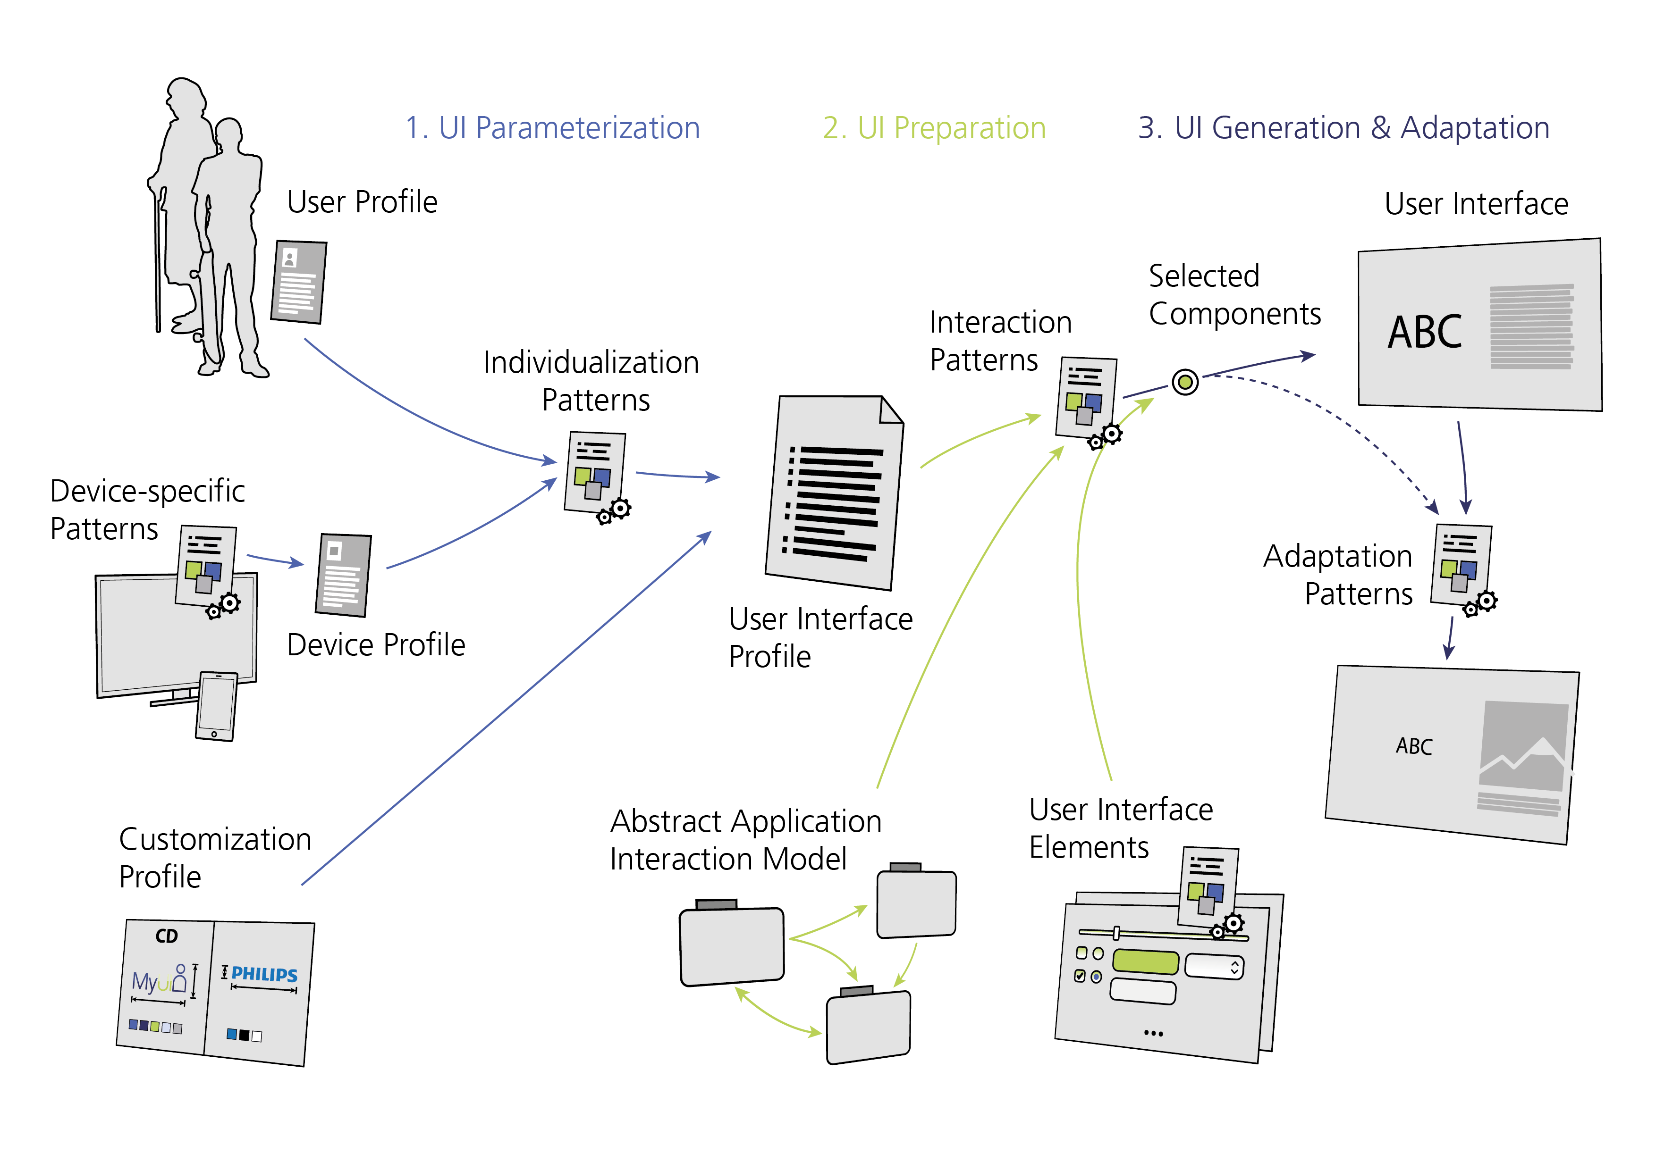
Figure 1 MyUI user interface generation and adaptation

MyUI design patterns
User interface generation and adaptation is done by the composition of multimodal user interface design patterns. Individual accessibility is achieved by combining design patterns that suit for a certain user and context. Adapting the user interface means switching from one design pattern of a cluster to another pattern of the same cluster which is hypothesized to fit best to the individual user’s needs.
The MyUI design patterns repository includes different categories of patterns. Each pattern type fulfills distinct functions in the MyUI adaptation framework (see Figure 1):
Device-specific patterns create a device profile on the basis of primitive device features as provided by the used I/O devices. Changes in the device setup will lead immediately to updating the device profile.
Individualization patterns define global user interface settings to fit individual user needs and specific context conditions, e.g. big font size for users with low vision or iconographic presentation for users with problems in language reception. As the available knowledge about the user and context can change during the interaction, individualization patterns play an important role for user interface adaptations during use.
These first two pattern types work on a general level of the user interface. Together, they are responsible for setting and adjusting global variables in the user interface profile. An additional input to the user interface profile comes from the customization profile which allows for corporate-, project- or brand-specific customizations.
Interaction patterns provide suitable user interface components for a current interaction situation as specified in the abstract application interaction model (AAIM), e.g. a list element for an interaction situation in which a user can select from a set of options. For each interaction situation, a bundle of different interaction design patterns exists. They differ in appearance or input mechanisms to support different user needs. The selection of the best suitable interaction pattern from a current bundle is done on the basis of specific variables of the user interface profile.
User interface elements are the building blocks for the interaction patterns. While interaction patterns can be regarded as components to support a given interaction situation, the user interface elements provide generic primitives required to compose the interaction patterns.
Adaptation patterns cover the dynamics of the adaptation processes, i.e. they define the mechanisms of switching from one instance of a user interface to another. Adaptation patterns are described in more detail in the next section.

MYUI ADAPTATION PATTERNS
Adaptation patterns are a major concept in the MyUI adaptation process. Their main purpose is to ensure high levels of transparency and controllability for the user in situations of adaptations during use.
User interface adaptations are executed by the MyUI Adaptation Engine. The adaptation engine recognizes mismatches of the user interface components currently displayed at the user interface and the components currently selected by the user interface preparation process. A mismatch triggers a run-time adaptation. Adaptations are performed by two types of MyUI adaptation patterns:
- Adaptation rendering patterns specify the graphical rendering process to smoothly but obviously switch from one user interface instance to another, e.g. animated transitions to grow small fonts to bigger fonts
- Adaptation dialogue patterns specify the interaction dialogue which takes place around the actual adaptation to make sure that the user is aware of the adaptation and can control the system’s adaptation behavior.

Adaptation rendering patterns
MyUI adaptation rendering patterns make extensive use of animations. They support orientation by creating continuity between the user interface before and after the adaptation. Animated transitions shall draw the end user’s attention to the screen areas where adaptations occur and shall help them to understand that and how the new user interface is a modification of the former user interface. When, for example, an increased font size results in hiding menu options which were directly available before the adaptation, an animation can communicate to the user that the hidden options are now available via the »more« button.

Adaptation dialogue patterns
Adaptation dialogue patterns specify the dialogue between the user interface and the MyUI user in the course of an adaptation. This dialogue typically includes a notification and interaction options for the user to influence the system’s adaptation behavior. In MyUI, two types of adaptation dialogue patterns are distinguished:
- System-initiated adaptation dialogue patterns are triggered by the system.
- User-initiated adaptation dialogue patterns describe customization dialogues in which the user modifies the user profile or the user interface profile.
The latter make MyUI a mixed-initiative system with adaptive and adaptable components. More interesting, however, are system-initiated adaptation dialogue patterns. They aim at increasing the usability and acceptability by making system-initiated adaptations more transparent and controllable. The MyUI patterns repository includes the following three system-initiated adaptation dialogue patterns:
- Explicit Confirmation before Adaptation: Before performing the adaptation the system requests the user to explicitly accept or reject the adaptation. The user’s decision is supported by providing a preview of the adaptation effect (Figure 2).
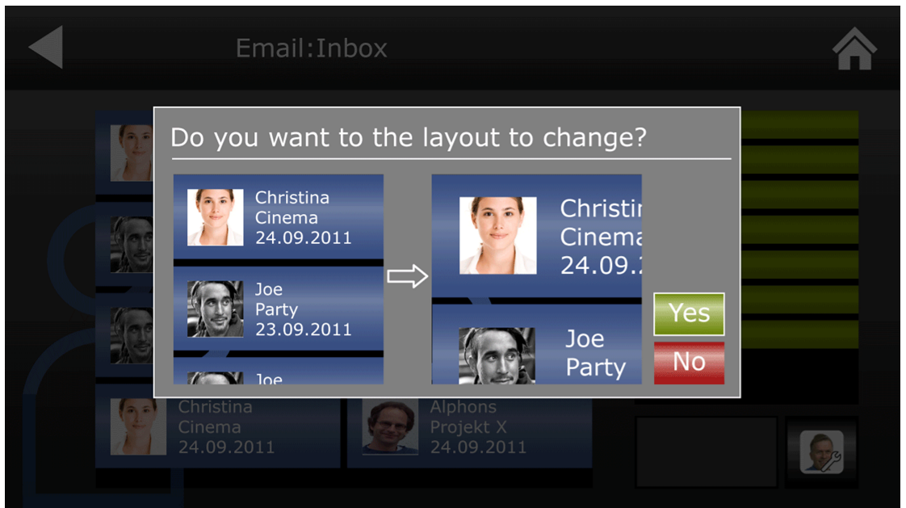
Figure 2 »Explicit Confirmation before Adaptation«: Dialogue box with preview (UI concept sketch)
- Explicit Confirmation after Adaptation: The adaptation is triggered and performed automatically. When the adaptation has been finished, a dialogue box asks the user if the changes shall be kept or undone.
- Automatic Adaptation with Implicit Confirmation: The adaptation is triggered and performed automatically. While rendering the adaptation, the system provides an icon-based notification about the on-going adaptation in a dedicated adaptation area on the screen. When the adaptation is finished the end user can undo the adaptation via a button in the adaptation area.

User study on adaptation dialogue patterns
We assume that the effectiveness and acceptability of the three adaptation dialogue patterns depend on a subjective cost-benefit judgment of the specific adaptation. Predominant costs might be associated with a higher wish for user control and therefore, a preference for explicit confirmations. However, in situations where the benefits outweigh the costs, user might prefer automatic adaptations because of their higher comfort of use. Findlater and Gajos also point to costs of adaptations, e.g. caused by incorrect adaptations or decreased aesthetics of the adapted UI [5]. In our case, adaptations can cause further costs, for example, when the adapted user interface requires additional interaction steps, e.g. increasing the font size requires extra scrolling. Benefits occur when an adaptation can actually increase the accessibility by eliminating a barrier of use.
Besides these situational factors, also personal traits might influence the subjective cost-benefit ratio and the preference of one of the adaptation dialogue patterns. Users with lower levels of ICT literacy or a higher need for security might tend to over-estimate the costs and therefore, prefer explicit confirmations.
We are currently preparing a user study addressing the following questions:
- Which adaptation dialogue patterns are most effective in terms of transparency, controllability and acceptance?
- Which pattern is preferred by the users?
- Do these measures differ in different cost-benefit conditions and for different users?
The results will be available by end of March 2012. They shall help us to design the mechanism for selecting the most appropriate adaptation pattern for different situations and user profiles.

REFERENCES
- Bunt, A., Conati, C., & McGrenere, J. (2009). A Mixed-Initiative Approach to Interface Personalization. AI Magazine 30(4).
- Coelho, J., Duarte, C., Biswas, P. & Langdon, P. (2011). Developing accessible TV applications. In The proceedings of the 13th international ACM SIGACCESS conference on Computers and accessibility (ASSETS '11). ACM, New York, 131-138.
- Dessart, C.-E., Motti, V. G. & Vanderdonckt, J. (2011). Showing user interface adaptivity by animated transitions. In Proceedings of the 3rd ACM SIGCHI symposium on Engineering interactive computing systems (EICS '11). ACM, New York, 95-104.
- Dieterich, H., Malinowski, U., Kühne, T. & Schneider-Hufschmidt, M. (1993). State of the Art in Adaptive User Interfaces. In: M. Schneider-Hufschmidt, T. Kühne & U. Malinowski (Eds.): Adaptive User Interfaces: Principles and practice. Amsterdam: North-Holland, 13–48.
- Findlater, L. & Gajos, K.Z. (2009). Design Space and Evaluation Challenges of Adaptive Graphical User Interfaces. AI Magazine 30(4).
- Findlater, L. & McGrenere, J. (2004) A comparison of static, adaptive, and adaptable menus. In Proceedings SIGCHI Conference on Human Factors in Computing Systems (CHI’04), New York: ACM, 89-96.
- Fischer, G. (1993). Shared knowledge in Cooperative Problem-Solving Systems – Integrating Adaptive and Adaptable Components. In: M. Schneider-Hufschmidt, T. Kühne & U. Malinowski (Eds.): Adaptive User Interfaces: Principles and practice. Amsterdam: North-Holland, 49–68.
- Gajos, K. Z., Weld, D. S., & Wobbrock, J. O. (2010). Automatically generating personalized user interfaces with Supple. Artificial Intelligence 174, 12-13. 910–950.
- Kobsa, A., Koenemann, J., & Pohl, W. (2001). Personalised hypermedia presentation techniques for improving online customer relationships. The Knowledge Engineering Review, Vol. 16:2, 111–155.
- Mackay, W. E. (1991). Triggers and barriers to customizing software, in: S. P. Robertson, G. M. Olson & J. S. Olson (Eds.). Proceedings of the SIGCHI Conference on Human Factors in Computing Systems (CHI ’91), New York: ACM. S. 153–160.
- MyUI Design Patterns Repository. Available at http://myuipatterns.clevercherry.com
- Peissner, M., Schuller, A. & Spath, D. (2011). A design patterns approach to adaptive user interfaces for users with special needs. In: J.A. Jacko (Ed.): Human-Computer Interaction, Part I, HCII 2011, LNCS 6761, Berlin: Springer-Verlag, pp. 268–277.
- Stephanidis, C., Paramythis, A., Sfyrakis, M., Stergiou, A., Maou, N., Leventis, A., Paparoulis, G. & Karagiannidis, C. (1998). Adaptable and adaptive user interfaces for disabled users in the AVANTI project, in: IS & N 98 Proceedings (1998), Springer-Verlag, 153-166.
- Weld, D., Anderson, C., Domingos, P., Etzioni, O., Lau, T., Gajos, K. & Wolfman, S. (2003). Automatically personalizing user interfaces. In Proceedings of the 18th international joint conference on Artificial intelligence (IJCAI'03). Morgan Kaufmann Publishers Inc., San Francisco, CA, USA, S. 1613-1619.

The columns on the last page should be of equal length.

This work was funded by the European Union MyUI project under grant FP7-ICT-248606
The current MyUI application prototypes run on a web-based iTV platform. The MyUI technical framework, however, is generic and not restricted to iTV.

