Step 1: Go to https://rap.city.ac.uk and enter your University username and password.

Step 2: The main screen:

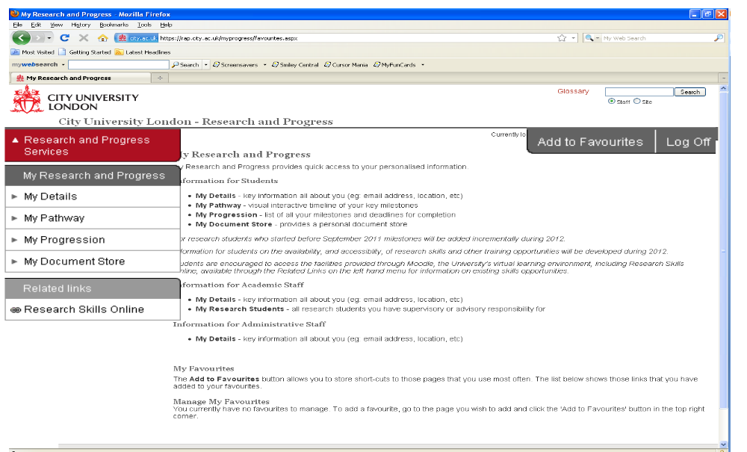
Research and Progress Services contains directories of information.
My Research and Progress contains your personal information and milestones
Click to log off
Add the current page to your favourites if you use it regularly

Step 3: My Pathway
My Pathway is a timeline image of your research programme showing key milestones.

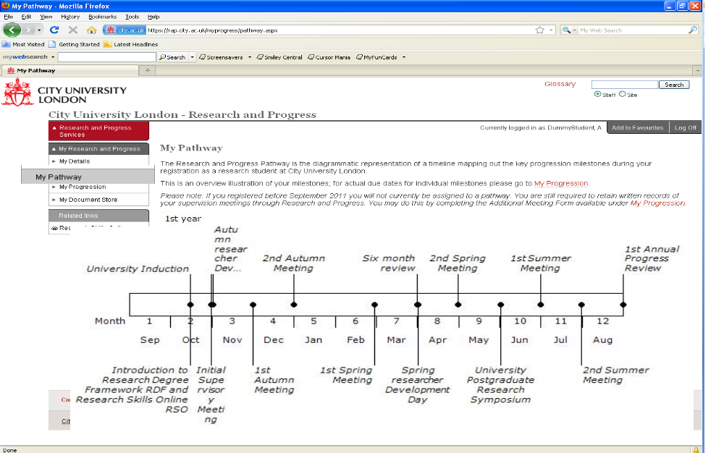
Click on the milestones to gain more information

Step 4: My Progression
My Progression is a full progression record of each milestone and activity related to your study.
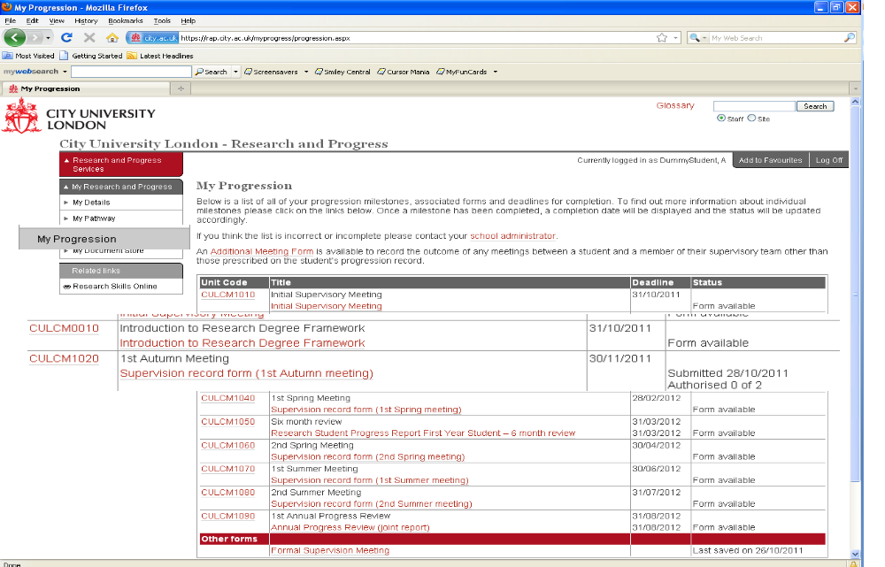
Rows are colour coded:
Red – the milestone form is overdue and needs to be saved and submitted.
Amber – the form is overdue and needs to be submitted, it has already been saved.
Green – the milestone is complete.
White – the milestone is in the future
Click on the form title to access the form where you can edit, save and submit

Step 5: Completing forms

Go to ‘My Progression’ and click on the relevant form.

Complete all relevant fields.

Click Save – this saves the content of the form

Return – goes back to ‘My Progression’

The Status will show the form has been saved, the tutor will then view the form, add their comments and submit the form. Once the form has been submitted it cannot be changed. Both the student and the supervisor will be invited to authorize the form.

